**208W1A12A0 DOT NET TECHNOLOGIES IT - B**

**Stock Management Application**

**DataBase Part :**

1. Open visual studio code and navigate to the “ View Section “ and then select the “ Server Explorer Option “
2. Then right click on the “ Data Connections “ and then click on “ Add Connection Option “
3. Now, select the “ Microsoft SQL Server Database File (sql Client) “ option
4. Then, create a Database with the name Stock management.

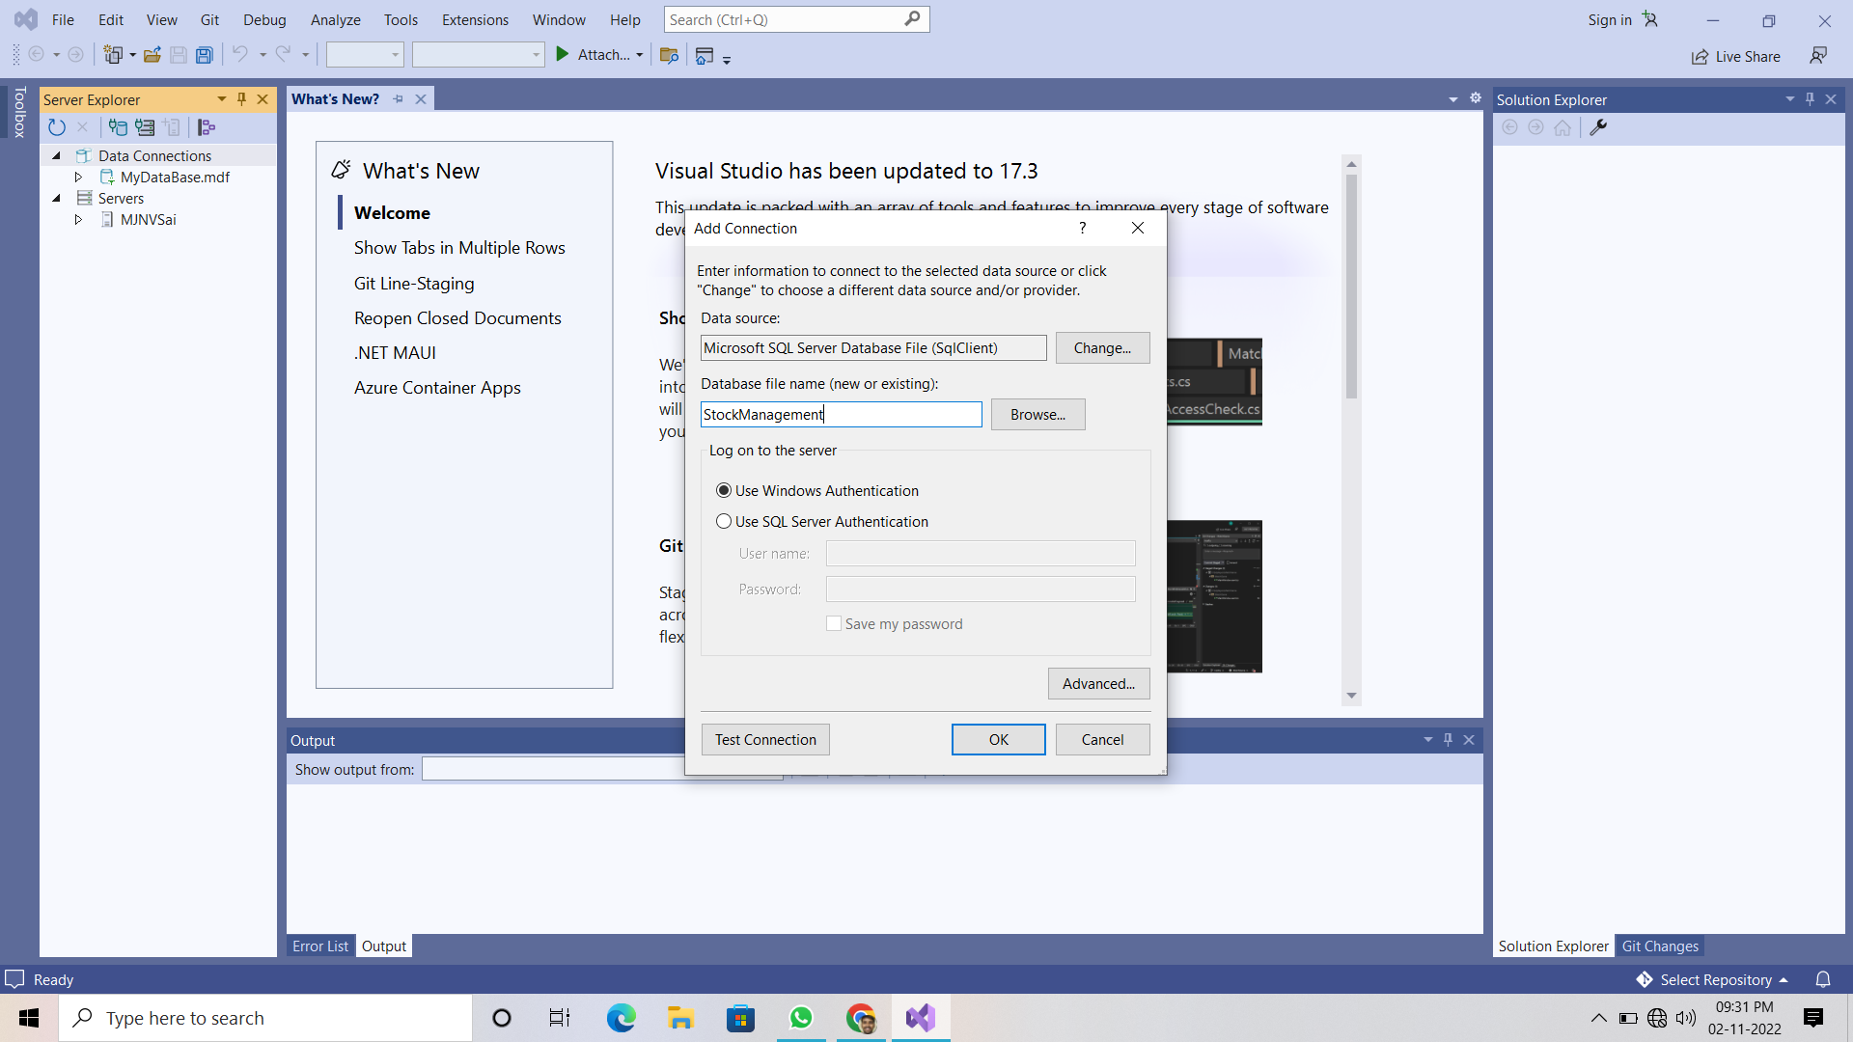

1. Now, create a 3 tables with the names Login, Stock, Products and their queries are below there :

|  |
| --- |
| **Login Table Query**  CREATE TABLE Login  (  [UserName] VARCHAR(50) NOT NULL PRIMARY KEY,  [Password] VARCHAR(50) NULL  )  **Products Table Query**  CREATE TABLE Products  (  [ProductCode] INT NOT NULL PRIMARY KEY,  [ProductName] VARCHAR(150) NULL,  [ProductStatus] BIT NULL  )  **Stocks Table Query**  CREATE TABLE Stock  (  [ProductCode] INT NOT NULL PRIMARY KEY,  [ProductName] VARCHAR(150) NULL,  [TransDate] DATETIME NULL,  [Quantity] FLOAT NULL  ) |

**Login Form Part :**

1. Open the New Project then select the windows form application and save it to the local machine.
2. navigate to the “ View Section “ and then select the “ Solution Explorer Option “
3. now, right click on the project name then click on “ ADD Component “ and then select the windows form application and save it as “Login.cs”
4. Now, design the Login Form Just like below one .

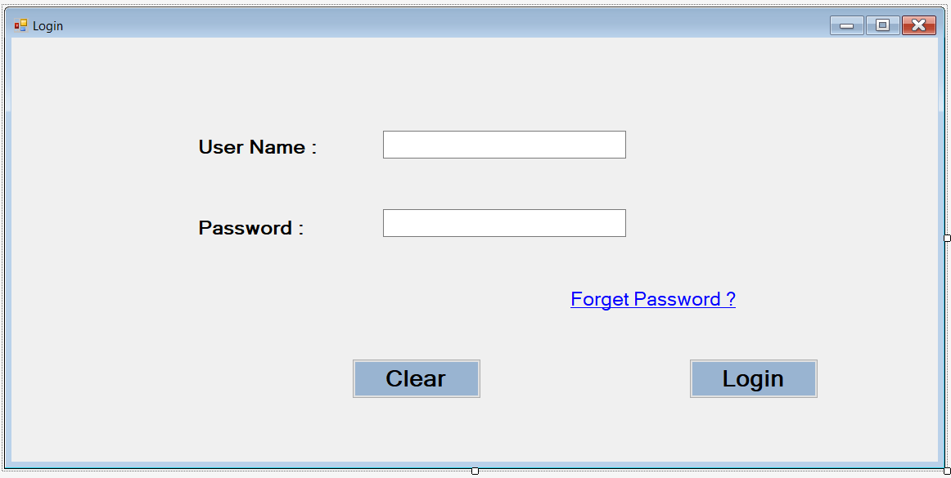

1. now, right click on the project name then click on “ ADD Component “ and then select the “ MDI Parent Form (Windows Forms) and save it as “StockMain.cs”

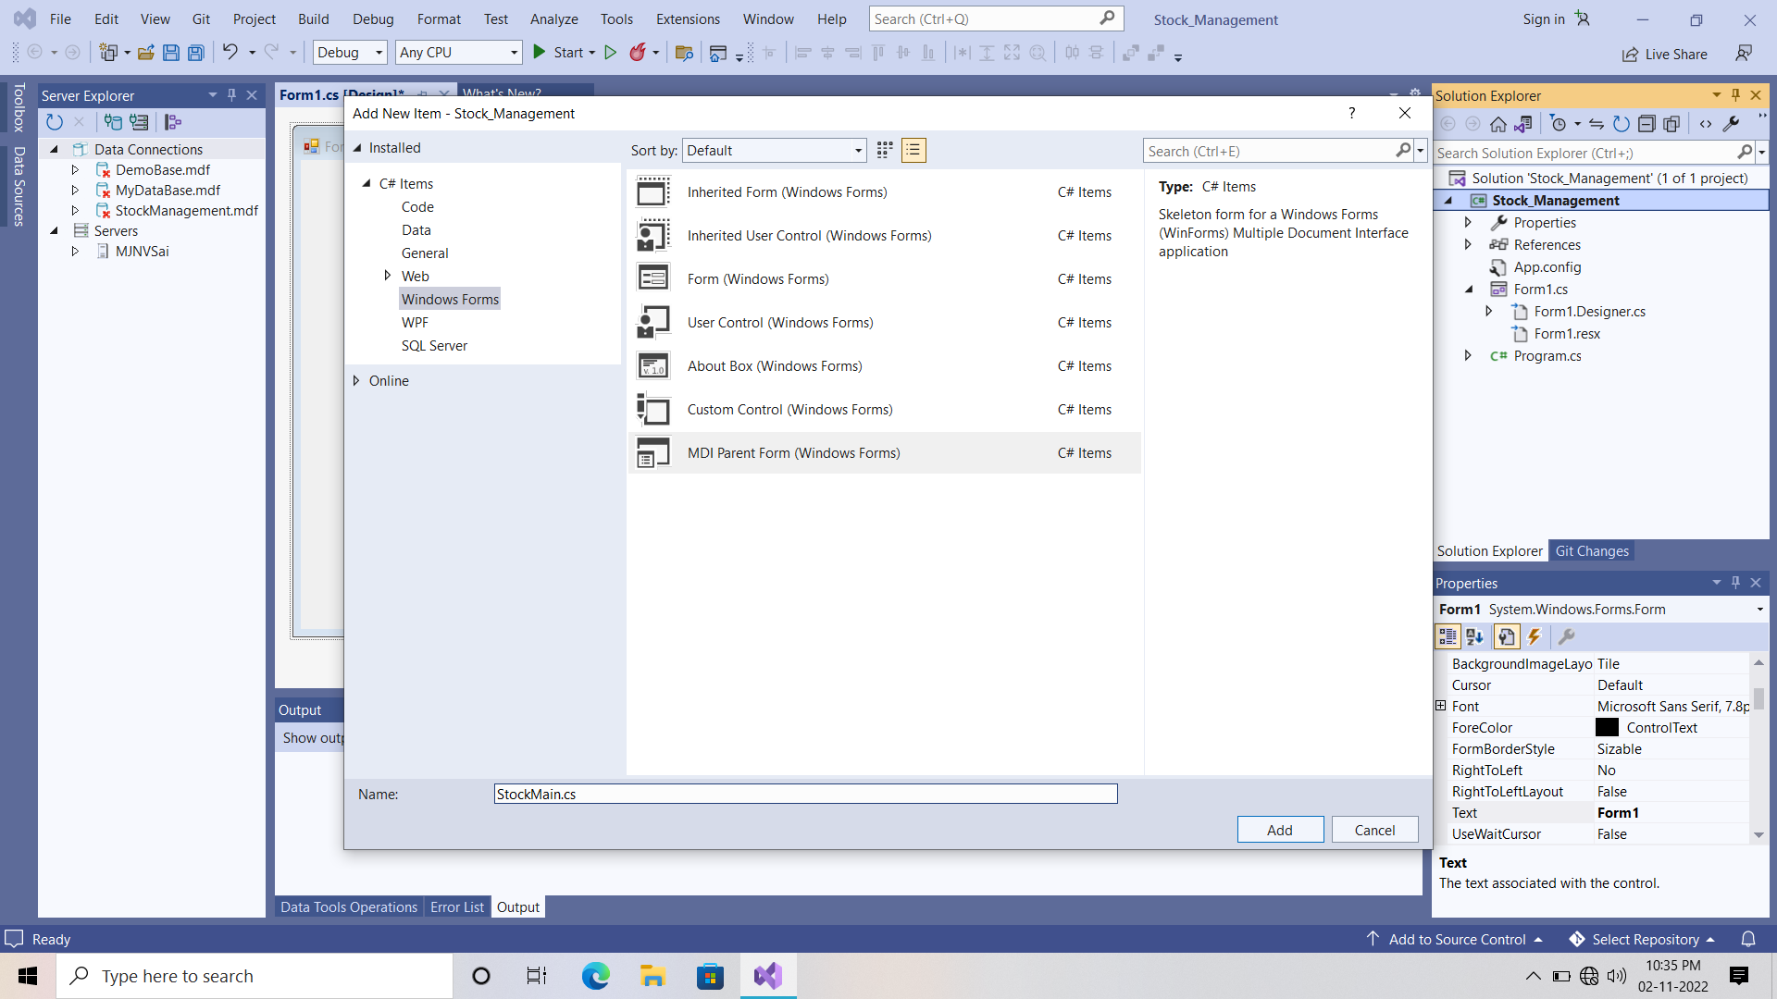

1. after adding this component you will see this is like and notepad .
2. now, remove all the items in the menu strip and the bar below the menu strip also.
3. Now, design this “StockMain.cs “ just like below one.

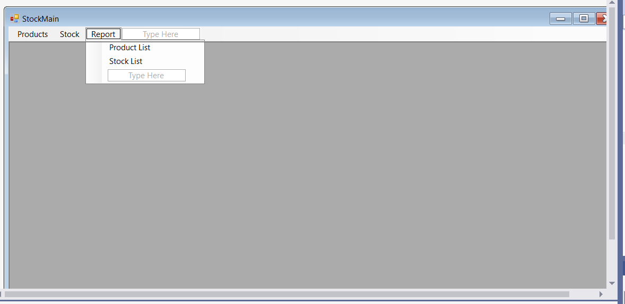

1. Now, we will write the C# Code for the “ StockMain.cs” and “ Login.cs”.
2. Then we will validate the Login Form details or credentials.
3. The codes for both “StockMain and login “ are there below one:

|  |
| --- |
| **Stock Main.cs**  using System;  using System.Collections.Generic;  using System.ComponentModel;  using System.Data;  using System.Drawing;  using System.Linq;  using System.Text;  using System.Threading.Tasks;  using System.Windows.Forms;  namespace Stock_Management  {  public partial class StockMain : Form  {  public StockMain()  {  InitializeComponent();  }  private void productsToolStripMenuItem_Click(object sender, EventArgs e)  {  // products option in Navbar  Products pro = new Products();  pro.MdiParent = this;  pro.StartPosition = FormStartPosition.CenterScreen;  pro.Show();  }  bool close = true;  private void StockMain_FormClosing(object sender, FormClosingEventArgs e)  {  if(close)  {  DialogResult result = MessageBox.Show(" Are You Sure Want To Exit ", "Exit", MessageBoxButtons.YesNo, MessageBoxIcon.Question);  if (result == DialogResult.Yes)  {  close = false;  Application.Exit();  }  else  {  e.Cancel = true;  }  }  }  }  } |

|  |
| --- |
| **Login Form Code**  using System;  using System.Collections.Generic;  using System.ComponentModel;  using System.Data;  using System.Drawing;  using System.Linq;  using System.Text;  using System.Threading.Tasks;  using System.Windows.Forms;  using System.Data.SqlClient; // add this line  namespace Stock_Management  {  public partial class Login : Form  {  public Login()  {  InitializeComponent();  }  private void button1_Click(object sender, EventArgs e)  {  // Clear Button  textBox1.Text = "";  textBox2.Clear();  textBox1.Focus();  }  private void button2_Click(object sender, EventArgs e)  {  // validating the Login Credentials  SqlConnection con = new SqlConnection("Data Source=(LocalDB)\\MSSQLLocalDB;AttachDbFilename=C:\\Users\\SHREEE\\OneDrive\\Documents\\StockManagement.mdf;Integrated Security=True;Connect Timeout=30");  con.Open();  SqlCommand cmd = new SqlCommand("select * from Login where UserName = @UserName and Password = @Password", con);  cmd.Parameters.AddWithValue("@UserName", textBox1.Text);  cmd.Parameters.AddWithValue("@Password", textBox2.Text);  cmd.ExecuteNonQuery();  SqlDataAdapter sda = new SqlDataAdapter(cmd);  DataTable dt = new DataTable();  sda.Fill(dt);  if(dt.Rows.Count == 1)  {  this.Hide();  StockMain main = new StockMain();  main.Show();  }  else  {  MessageBox.Show("Invalid Usename and password ... !", "Error", MessageBoxButtons.OK, MessageBoxIcon.Error);  button1_Click(sender, e);  }  con.Close();  // Login Button  }  }  }  **Note :**  Use the Connection String of Your Own DataBase. |

**Connection String Part :**

1. When we are writing the coding part in back of the form we mostly use the database connection string many times and this string is very large.
2. So, to reduce the database connection string we can do some minur changes in the “ App.config “ and the code is below there

|  |
| --- |
| **App.Config**  <?xml version="1.0" encoding="utf-8" ?>  <configuration>  <startup>  <supportedRuntime version="v4.0" sku=".NETFramework,Version=v4.7.2" />  </startup>  <connectionStrings>  <add name ="StockConn" connectionString="Data Source=(LocalDB)\MSSQLLocalDB;AttachDbFilename=C:\Users\SHREEE\OneDrive\Documents\StockManagement.mdf;Integrated Security=True;Connect Timeout=30" providerName="System.Data.SqlClient" />  </connectionStrings>    </configuration> |

1. After modifying the code in app.config we have to add a component.
2. now, right click on the project name then click on “ ADD Component “ and then select the “ Class “ and save it as “Connection.cs”
3. In this connection.cs file we will write the only single static function and it is invoked when we want to use the database connection string.

|  |
| --- |
| **Connection.cs**  using System;  using System.Collections.Generic;  using System.Linq;  using System.Text;  using System.Threading.Tasks;  using System.Data.SqlClient;  namespace Stock_Management  {  public static class Connection  {  public static SqlConnection getConnection()  {  SqlConnection con = new SqlConnection();  con.ConnectionString = System.Configuration.ConfigurationManager.ConnectionStrings["StockConn"].ConnectionString;  return con;  }  }  } |

**Products Form :**

1. now, right click on the project name then click on “ ADD Component “ and then select the “ Windows Forms “ and save it as “products.cs”
2. navigate to the Form Tool Box and search for “ Error provider “

and double click on that then navigate to the Product.cs

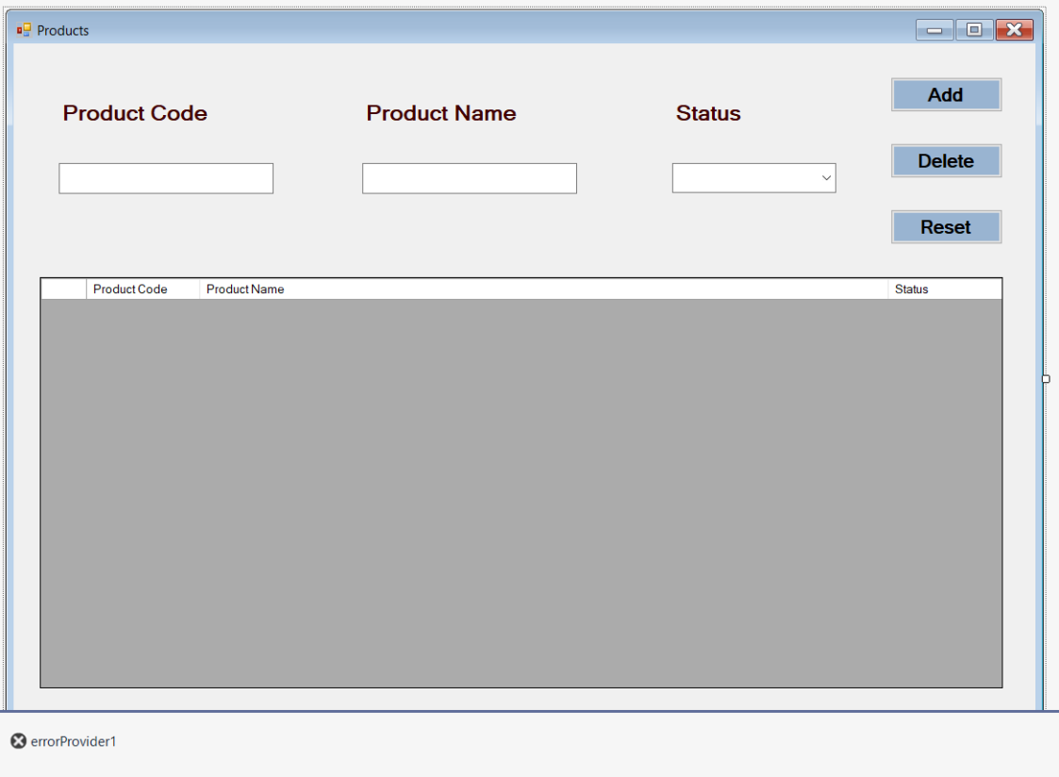

1. When you add combo box to the status then in drop down add these 2 parameters also they are “ Active & Deactive “.
2. The code for products form will below there :

|  |
| --- |
| **Products Form Code**  using System;  using System.Collections.Generic;  using System.ComponentModel;  using System.Data;  using System.Drawing;  using System.Linq;  using System.Text;  using System.Threading.Tasks;  using System.Windows.Forms;  using System.Data.SqlClient;  using static System.Windows.Forms.VisualStyles.VisualStyleElement;  namespace Stock_Management  {  public partial class Products : Form  {  public Products()  {  InitializeComponent();  }  private void Products_Load(object sender, EventArgs e)  {  comboBox1.SelectedIndex = 0;  LoadData();  }  private void button1_Click(object sender, EventArgs e)  {  // Add button  if(Validation())  {  SqlConnection con = Connection.getConnection();  con.Open();  bool status = false;  if (comboBox1.SelectedIndex == 0)  {  status = true;  }  else  {  status = false;  }  var sqlquery = "";  if (IfProductExists(con, textBox1.Text))  {  sqlquery = "update Products set ProductName = @ProductName, ProductStatus = @ProductStatus where ProductCode = @ProductCode";  }  else  {  sqlquery = "insert into Products values(@ProductCode, @ProductName, @ProductStatus)";  }  SqlCommand cmd = new SqlCommand(sqlquery, con);  cmd.Parameters.AddWithValue("@ProductCode", int.Parse(textBox1.Text));  cmd.Parameters.AddWithValue("@ProductName", textBox2.Text);  cmd.Parameters.AddWithValue("@ProductStatus", status);  cmd.ExecuteNonQuery();  con.Close();  LoadData();  ResetRecords(); //..  }    }  private bool IfProductExists(SqlConnection con, string productCode)  {  SqlDataAdapter sda = new SqlDataAdapter("select 1 from Products where ProductCode = '"+ productCode + "'", con);  DataTable dt = new DataTable();  sda.Fill(dt);  if(dt.Rows.Count > 0)  {  return true;  }  else  {  return false;  }  }  public void LoadData()  {  SqlConnection con = Connection.getConnection();  con.Open();  SqlDataAdapter sda = new SqlDataAdapter("select * from Products", con);  DataTable dt = new DataTable();  sda.Fill(dt);  dataGridView1.Rows.Clear();  foreach (DataRow item in dt.Rows)  {  int n = dataGridView1.Rows.Add();  if ((bool)item["ProductStatus"])  {  dataGridView1.Rows[n].Cells[2].Value = "Active";  }  else  {  dataGridView1.Rows[n].Cells[2].Value = "Deactive";  }  dataGridView1.Rows[n].Cells[0].Value = item["ProductCode"].ToString();  dataGridView1.Rows[n].Cells[1].Value = item["ProductName"].ToString();  //dataGridView1.Rows[n].Cells[0].Value = item["ProductStatus"].ToString();  }  }  private void dataGridView1_MouseDoubleClick(object sender, MouseEventArgs e)  {  button1.Text = "Update"; //..    textBox1.Text = dataGridView1.SelectedRows[0].Cells[0].Value.ToString();  textBox2.Text = dataGridView1.SelectedRows[0].Cells[1].Value.ToString();  //comboBox1.SelectedText = dataGridView1.SelectedRows[0].Cells[2].Value.ToString();  if(dataGridView1.SelectedRows[0].Cells[2].Value.ToString() == "Active")  {  comboBox1.SelectedIndex = 0;  }  else  {  comboBox1.SelectedIndex = 1;  }  }  private void button2_Click(object sender, EventArgs e)  {  // Delete button  DialogResult dialogResult = MessageBox.Show(" Are You Sure Want To Delete ", "Message", MessageBoxButtons.YesNo);  if(dialogResult == DialogResult.Yes)  {  if (Validation())  {  SqlConnection con = Connection.getConnection();  con.Open();  var sqlquery = "";  if (IfProductExists(con, textBox1.Text))  {  sqlquery = "delete from Products where ProductCode = @ProductCode";  SqlCommand cmd = new SqlCommand(sqlquery, con);  cmd.Parameters.AddWithValue("@ProductCode", int.Parse(textBox1.Text));  cmd.ExecuteNonQuery();  }  else  {  MessageBox.Show("Record Doesn't Exists in the table ..... !");  }  con.Close();  LoadData();  ResetRecords();  }  }      }  private void ResetRecords()  {  //..  textBox1.Clear();  textBox2.Clear();  comboBox1.SelectedIndex = -1;  button1.Text = "Add";  textBox1.Focus();  }  private void button3_Click(object sender, EventArgs e)  {  // ..  ResetRecords();  }  private bool Validation()  {  // ..  bool result = false;    if(string.IsNullOrEmpty(textBox1.Text))  {  errorProvider1.Clear();  errorProvider1.SetError(textBox1, " Product Code required ");  }  else if(string.IsNullOrEmpty(textBox2.Text))  {  errorProvider1.Clear();  errorProvider1.SetError(textBox2, " Product Name Required ");  }  else if(comboBox1.SelectedIndex == -1)  {  errorProvider1.Clear();  errorProvider1.SetError(comboBox1, " Select the status ");  }  else  {  return true;  }  return result;  }  }  }  **Note :**  Use the Connection String of Your Own DataBase. |

**Stock Form :**

1. now, right click on the project name then click on “ ADD Component “ and then select the “ Windows Forms “ and save it as “stock.cs”
2. navigate to the Form Tool Box and search for “ Error provider “

and double click on that then navigate to the stock.cs

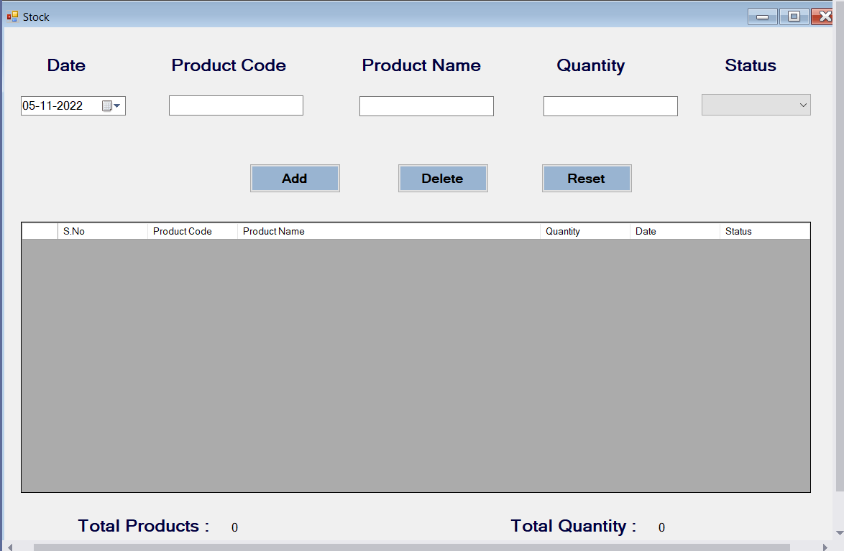

1. When you add combo box to the status then in drop down add these 2 parameters also they are “ Active & Deactive “.
2. The code for Stock form will below there :

|  |
| --- |
| **Stock.cs Code**  using System;  using System.Collections.Generic;  using System.ComponentModel;  using System.Data;  using System.Data.SqlClient;  using System.Drawing;  using System.Linq;  using System.Text;  using System.Threading.Tasks;  using System.Windows.Forms;  using System.Data.SqlClient;  namespace Stock_Management  {  public partial class Stock : Form  {  public Stock()  {  InitializeComponent();  }  private void Stock_Load(object sender, EventArgs e)  {  this.ActiveControl = dateTimePicker1;  comboBox1.SelectedIndex = 0;  LoadData();  Search();  }  private void dateTimePicker1_KeyDown(object sender, KeyEventArgs e)  {  if(e.KeyCode == Keys.Enter)  {  textBox1.Focus();  }  }  private void textBox1_KeyDown(object sender, KeyEventArgs e)  {  if(e.KeyCode == Keys.Enter)  {  if(dgview.Rows.Count > 0)  {  textBox1.Text = dgview.SelectedRows[0].Cells[0].Value.ToString();  textBox2.Text = dgview.SelectedRows[0].Cells[1].Value.ToString();  this.dgview.Visible = false;  textBox3.Focus();  }  else  {  this.dgview.Visible = false;  }  }  }  private void textBox2_KeyDown(object sender, KeyEventArgs e)  {  if(e.KeyCode == Keys.Enter)  {  if(textBox2.Text.Length > 0)  {  textBox3.Focus();  }  else  {  textBox2.Focus();  }  }  }  bool change = true;  private void proCode_MouseDoubleClick(object sender, MouseEventArgs e)  {  if (change)  {  change = false;  textBox1.Text = dgview.SelectedRows[0].Cells[0].Value.ToString();  textBox2.Text = dgview.SelectedRows[0].Cells[1].Value.ToString();  this.dgview.Visible = false;  textBox3.Focus();  change = true;  }  }  private void textBox3_KeyDown(object sender, KeyEventArgs e)  {  if(e.KeyCode == Keys.Enter)  {  if(textBox3.Text.Length > 0)  {  comboBox1.Focus();  }  else  {  textBox3.Focus();  }  }  }  private void comboBox1_KeyDown(object sender, KeyEventArgs e)  {  if(e.KeyCode == Keys.Enter)  {  if(comboBox1.SelectedIndex != -1)  {  button1.Focus();  }  else  {  comboBox1.Focus();  }  }  }  private void textBox1_KeyPress(object sender, KeyPressEventArgs e)  {  if(!char.IsNumber(e.KeyChar) & (Keys)e.KeyChar != Keys.Back & e.KeyChar != '.')  {  e.Handled = true;  }  }  private void textBox3_KeyPress(object sender, KeyPressEventArgs e)  {  if (!char.IsNumber(e.KeyChar) & (Keys)e.KeyChar != Keys.Back & e.KeyChar != '.')  {  e.Handled = true;  }  }  private void ResetRecords()  {  dateTimePicker1.Value = DateTime.Now;  textBox1.Clear();  textBox2.Clear();  textBox3.Clear();  comboBox1.SelectedIndex = -1;  button1.Text = "Add";  dateTimePicker1.Focus();  }  private void button3_Click(object sender, EventArgs e)  {  ResetRecords();  }  private bool Validation()  {  bool result = false;  if(string.IsNullOrEmpty(textBox1.Text))  {  errorProvider1.Clear();  errorProvider1.SetError(textBox1, " Product Code Required ");  }  else if(string.IsNullOrEmpty(textBox2.Text))  {  errorProvider1.Clear();  errorProvider1.SetError(textBox2, " Product Name Required ");  }  else if(string.IsNullOrEmpty(textBox3.Text))  {  errorProvider1.Clear();  errorProvider1.SetError(textBox3, " Quantity Required ");  }  else if(comboBox1.SelectedIndex == -1)  {  errorProvider1.Clear();  errorProvider1.SetError(comboBox1, " Select Status ");  }  else  {  errorProvider1.Clear();  result = true;  }  return result;  }  private bool IfProductExists(SqlConnection con, string productCode)  {  SqlDataAdapter sda = new SqlDataAdapter("select 1 from Stock where ProductCode = '" + productCode + "'", con);  DataTable dt = new DataTable();  sda.Fill(dt);  if (dt.Rows.Count > 0)  {  return true;  }  else  {  return false;  }  }  private void button1_Click(object sender, EventArgs e)  {  // Add Button  if(Validation())  {  SqlConnection con = Connection.getConnection();  con.Open();  bool status = false;  if(comboBox1.SelectedIndex == 0)  {  status = true;  }  else  {  status = false;  }  var sqlquery = "";  if (IfProductExists(con, textBox1.Text))  {  sqlquery = "update Stock set ProductName = @ProductName, ProductStatus = @ProductStatus, Quantity = @Quantity where ProductCode = @ProductCode";  }  else  {  sqlquery = "insert into Stock values(@ProductCode, @ProductName, @TransDate, @Quantity, @ProductStatus)";  }  SqlCommand cmd = new SqlCommand(sqlquery, con);  cmd.Parameters.AddWithValue("@ProductCode", int.Parse(textBox1.Text));  cmd.Parameters.AddWithValue("@ProductName", textBox2.Text);  cmd.Parameters.AddWithValue("@TransDate", dateTimePicker1.Value.ToString("MM/dd/yyyy"));  cmd.Parameters.AddWithValue("@Quantity", textBox3.Text);  cmd.Parameters.AddWithValue("@ProductStatus", status);  cmd.ExecuteNonQuery();  con.Close();  MessageBox.Show(" Record Saved Successfully ");  LoadData();  ResetRecords(); //..  }  }  public void LoadData()  {  SqlConnection con = Connection.getConnection();  SqlDataAdapter sda = new SqlDataAdapter("select * from Stock", con);  DataTable dt = new DataTable();  sda.Fill(dt);  dataGridView1.Rows.Clear();  foreach(DataRow item in dt.Rows)  {  int n = dataGridView1.Rows.Add();  dataGridView1.Rows[n].Cells["dgSno"].Value = n + 1;  dataGridView1.Rows[n].Cells["dgProCode"].Value = item["ProductCode"].ToString();  dataGridView1.Rows[n].Cells["dgProName"].Value = item["ProductName"].ToString();  dataGridView1.Rows[n].Cells["dgQuantity"].Value = float.Parse(item["Quantity"].ToString());  dataGridView1.Rows[n].Cells["dgDate"].Value = Convert.ToDateTime(item["TransDate"].ToString()).ToString("dd/MM/yyyy");  if ((bool)item["ProductStatus"])  {  dataGridView1.Rows[n].Cells["dgStatus"].Value = "Active";  }  else  {  dataGridView1.Rows[n].Cells["dgStatus"].Value = "Deactive";  }  }  if(dataGridView1.Rows.Count > 0)  {  label8.Text = dataGridView1.Rows.Count.ToString();  float totQty = 0;  for(int i = 0; i < dataGridView1.Rows.Count; ++i)  {  totQty += float.Parse(dataGridView1.Rows[i].Cells["dgQuantity"].Value.ToString());  label9.Text = totQty.ToString();  }  }  else  {  label8.Text = "0";  label9.Text = "0";  }  }  private void dataGridView1_MouseDoubleClick(object sender, MouseEventArgs e)  {  button1.Text = "Update";  textBox1.Text = dataGridView1.SelectedRows[0].Cells["dgProCode"].Value.ToString();  textBox2.Text = dataGridView1.SelectedRows[0].Cells["dgProName"].Value.ToString();  textBox3.Text = dataGridView1.SelectedRows[0].Cells["dgQuantity"].Value.ToString();  dateTimePicker1.Text = DateTime.Parse(dataGridView1.SelectedRows[0].Cells["dgDate"].Value.ToString()).ToString("dd/MM/yyyy");  if (dataGridView1.SelectedRows[0].Cells["dgStatus"].Value.ToString() == "Active")  {  comboBox1.SelectedIndex = 0;  }  else  {  comboBox1.SelectedIndex = 1;  }  }  private void button2_Click(object sender, EventArgs e)  {  // Delete Button  DialogResult dialogResult = MessageBox.Show(" Are You Sure Want To Delete ", "Message", MessageBoxButtons.YesNo);  if (dialogResult == DialogResult.Yes)  {  if (Validation())  {  SqlConnection con = Connection.getConnection();  con.Open();  var sqlquery = "";  if (IfProductExists(con, textBox1.Text))  {  sqlquery = "delete from Stock where ProductCode = @ProductCode";  SqlCommand cmd = new SqlCommand(sqlquery, con);  cmd.Parameters.AddWithValue("@ProductCode", int.Parse(textBox1.Text));  cmd.ExecuteNonQuery();  }  else  {  MessageBox.Show("Record Doesn't Exists in the table ..... !");  }  con.Close();  LoadData();  ResetRecords();  }  }  }  private void textBox1_TextChanged(object sender, EventArgs e)  {  // product Code textbox  if(textBox1.Text.Length > 0)  {  this.dgview.Visible = true;  dgview.BringToFront();  Search(150, 105, 430, 200, "Pro Code, Pro Name", "100");  // To do : mouse Double Click Event  this.dgview.MouseDoubleClick += new System.Windows.Forms.MouseEventHandler(this.proCode_MouseDoubleClick);    SqlConnection con = Connection.getConnection();  con.Open();  SqlCommand cmd = new SqlCommand("select Top(10) ProductCode, ProductName from Products where ProductCode like @ProductCode", con);  cmd.Parameters.AddWithValue("@ProductCode", int.Parse(textBox1.Text));  SqlDataAdapter sda = new SqlDataAdapter(cmd);  DataTable dt = new DataTable();  sda.Fill(dt);  dgview.Rows.Clear();  foreach(DataRow row in dt.Rows)  {  int n = dgview.Rows.Add();  dgview.Rows[n].Cells[0].Value = row["ProductCode"].ToString();  dgview.Rows[n].Cells[1].Value = row["ProductName"].ToString();  }  }  else  {  dgview.Visible = false;  }  }  private DataGridView dgview;  private DataGridViewTextBoxColumn dgviewcol1;  private DataGridViewTextBoxColumn dgviewcol2;  void Search()  {  dgview = new DataGridView();  dgviewcol1 = new DataGridViewTextBoxColumn();  dgviewcol2 = new DataGridViewTextBoxColumn();  this.dgview.ColumnHeadersHeightSizeMode = System.Windows.Forms.DataGridViewColumnHeadersHeightSizeMode.AutoSize;  this.dgview.Columns.AddRange(new System.Windows.Forms.DataGridViewColumn[] { this.dgviewcol1, this.dgviewcol2 });  this.dgview.Name = "dgview";  dgview.Visible = false;  this.dgviewcol2.AutoSizeMode = DataGridViewAutoSizeColumnMode.Fill;  this.dgviewcol1.Visible = false;  this.dgviewcol2.Visible = false;  this.dgview.AllowUserToAddRows = false;  this.dgview.RowHeadersVisible = false;  this.dgview.SelectionMode = System.Windows.Forms.DataGridViewSelectionMode.FullRowSelect;  //this.dgview.KeyDown += new System.Windows.Forms.KeyEventHandler(this.dgview_KeyDown);  this.Controls.Add(dgview);  this.dgview.ReadOnly = true;  dgview.BringToFront();  }  //Two Column  void Search(int LX, int LY, int DW, int DH, string ColName, String ColSize)  {  this.dgview.Location = new System.Drawing.Point(LX, LY);  this.dgview.Size = new System.Drawing.Size(DW, DH);  string[] ClSize = ColSize.Split(',');  //Size  for(int i = 0; i < ClSize.Length; i++)  {  if(int.Parse(ClSize[i]) != 0)  {  dgview.Columns[i].Width = int.Parse(ClSize[i]);  }  else  {  dgview.Columns[i].AutoSizeMode = System.Windows.Forms.DataGridViewAutoSizeColumnMode.Fill;  }  }  //Name  string[] ClName = ColName.Split(',');  for (int i = 0; i < ClName.Length; i++)  {  this.dgview.Columns[i].HeaderText = ClName[i];  this.dgview.Columns[i].Visible = true;  }  }  }  } |

**Installation Of The Crystal Reporting Services Tool**

1. Before we go for the generating the reports for the products and stock windows form.
2. First we have to install the crystal reporting services tool in your systems.
3. Download the crystal reporting services from the below link

https://drive.google.com/file/d/1AEuZ2AM-5B1daK0BAQEhRQCNqHbe-dim/view?usp=sharing

1. After downloading the file then unzip the rar file you will see there are 3 files in that folder.

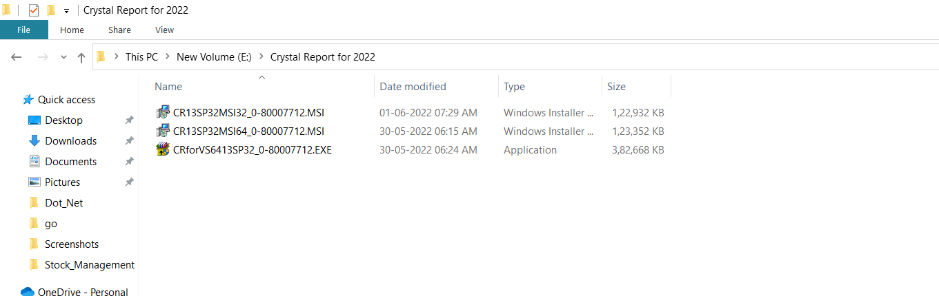

1. First run the “ Second File “ and give all permissons and access to the tool.
2. Next run the “ Last File “ and give all permissons and access to the tool.

**Sample Installation Pic :**

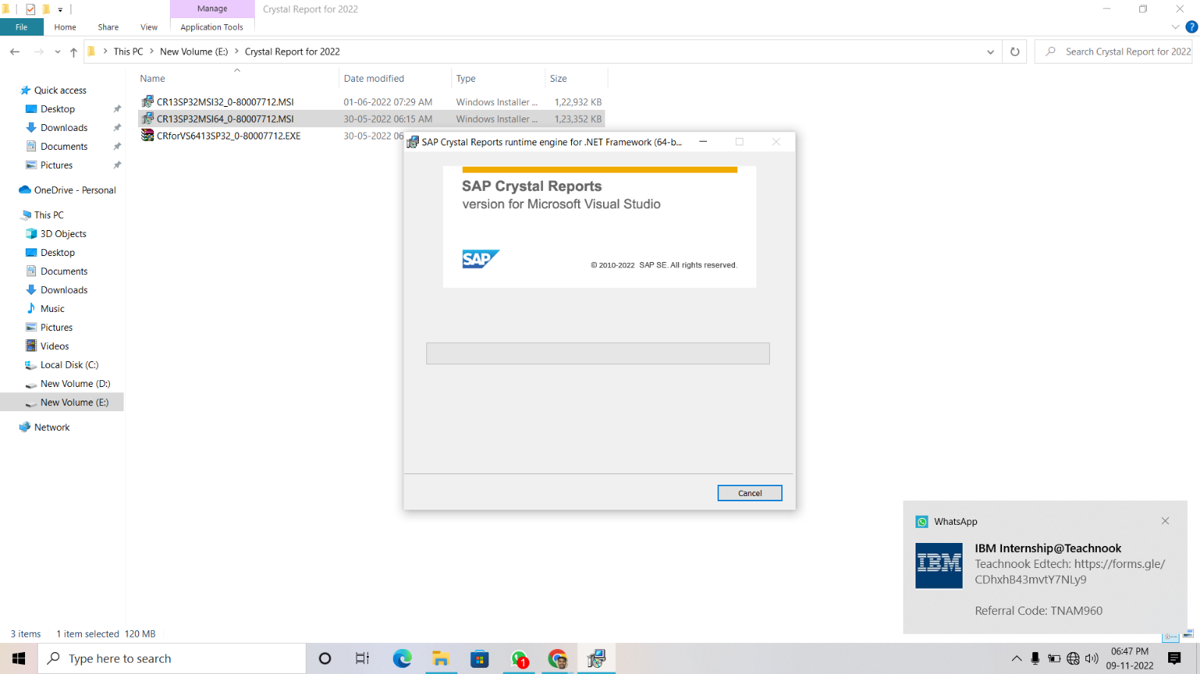

**Dataset Creation Part**

1. Open the solution explorer and right click on project name and create a 3 new folders with Names “ Datas “, “ ReportForm “

“ Reports “ just like below one.

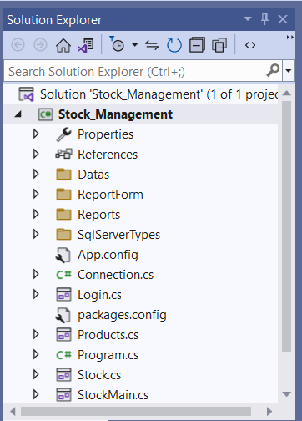

1. Now right click on Project name and choose “ Add item option”

And then select the Dataset option.

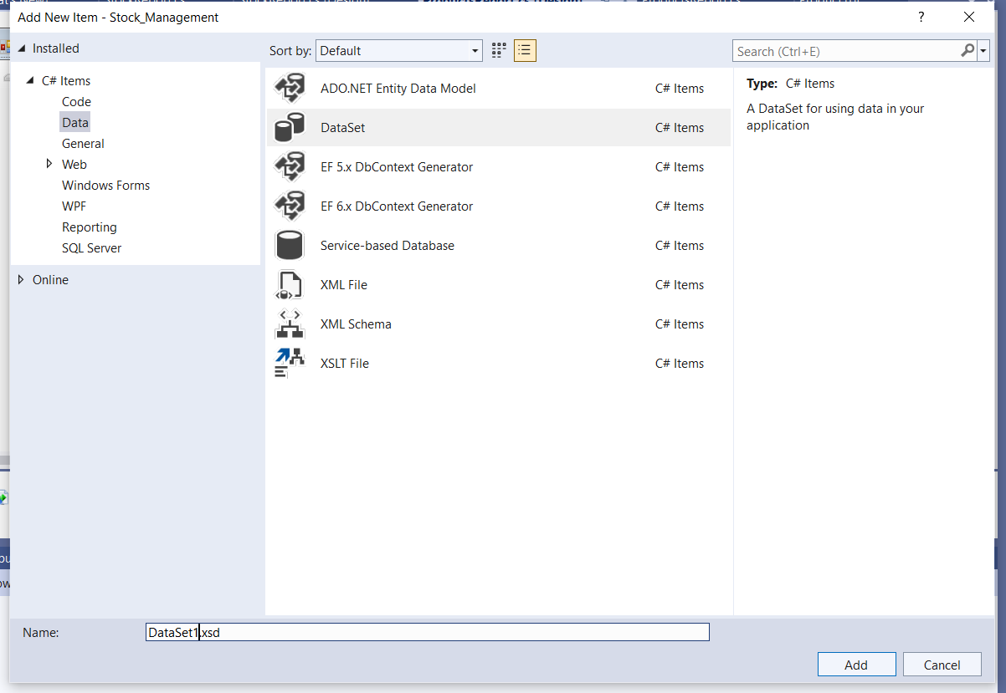

1. After creating it “ Double click on the DataSet1.xsd “ and just drag the

Products and Stock tables from the server explorer into the DataSet1.xsd

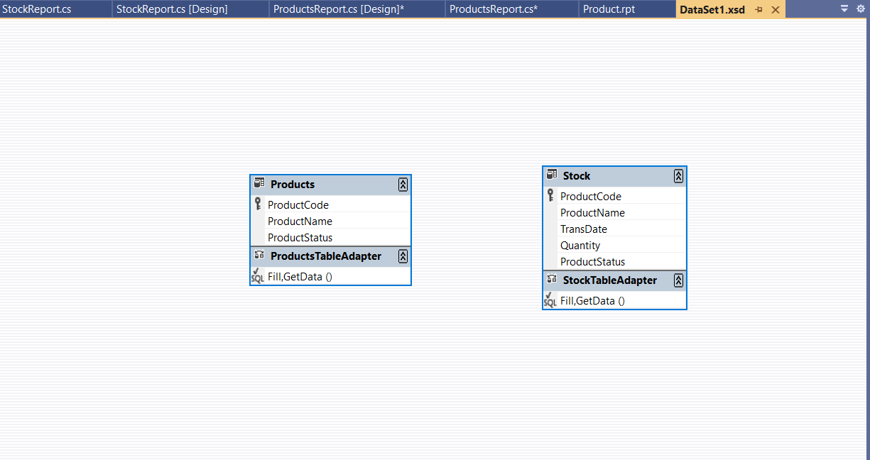

**Product Report Part**

1. Right click on the reports folder and then add an item crystal reporting and save as Product.rpt

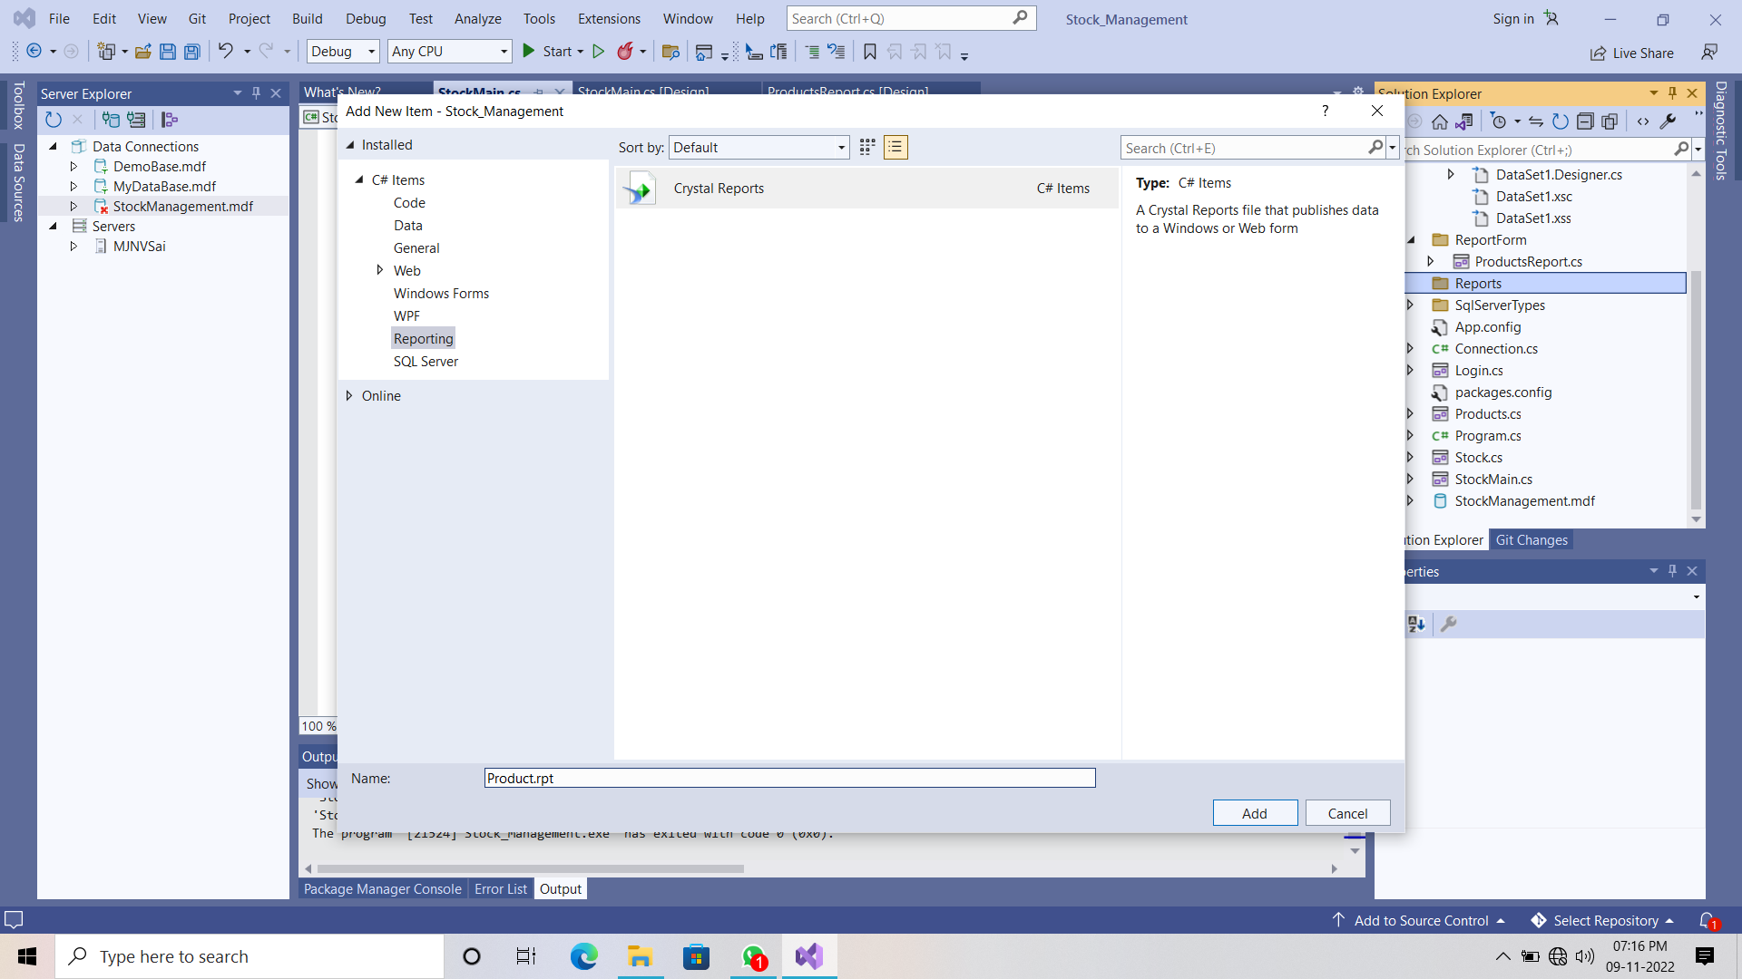

1. Select the Blank report option and click on ok.

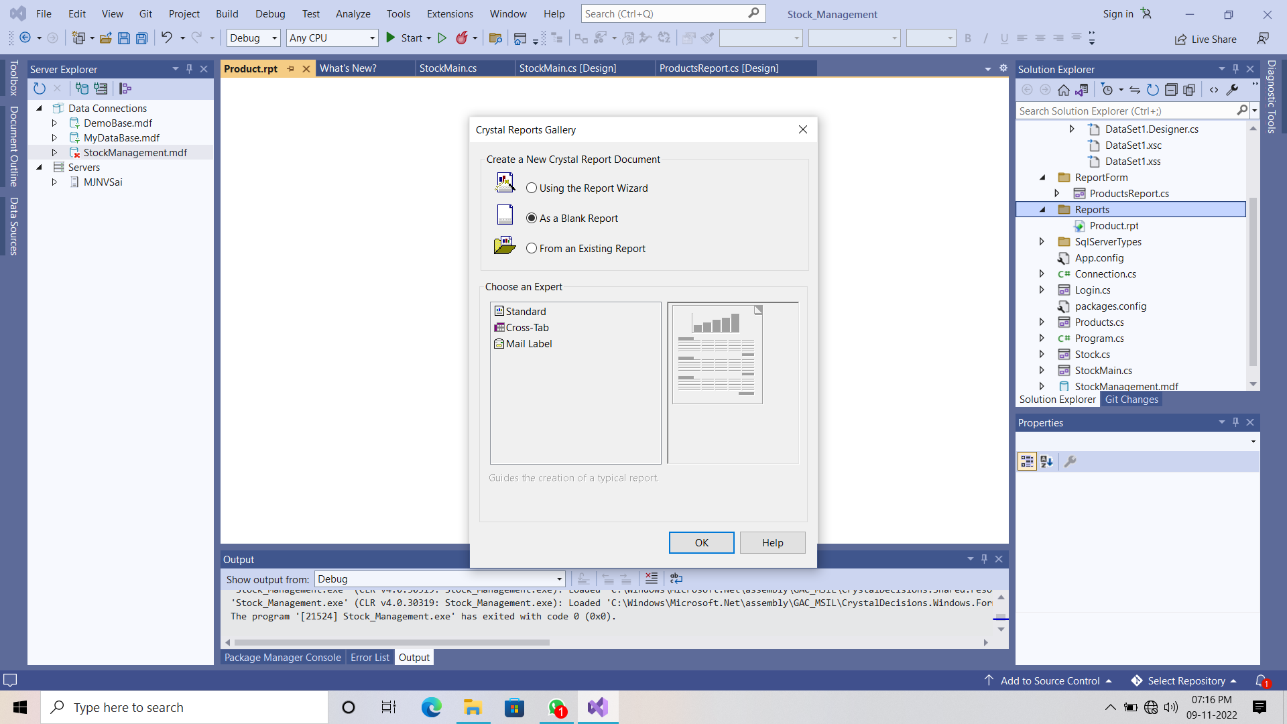

1. Now right click on the section 1 and select the page setup

Change the Letter format to the A4 sheet format.

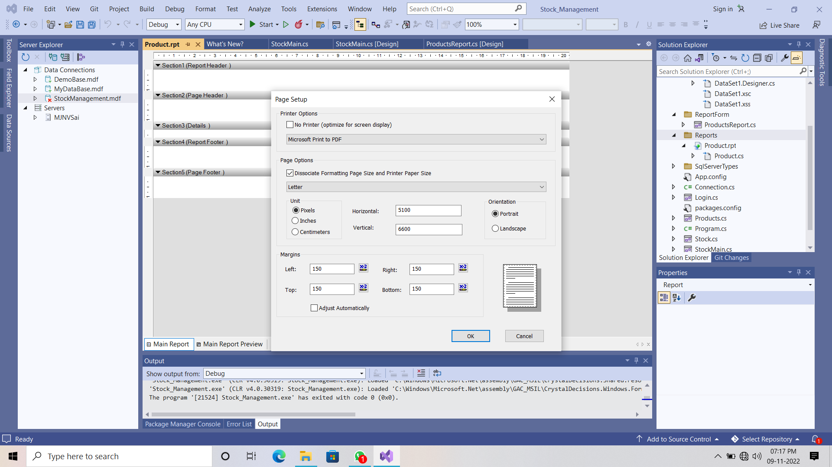

1. To write on the report , to print the date , row number in any section you just right click on that section you will get the options releated to that.

For example you want textfield you can select or you date option then go to the special field.

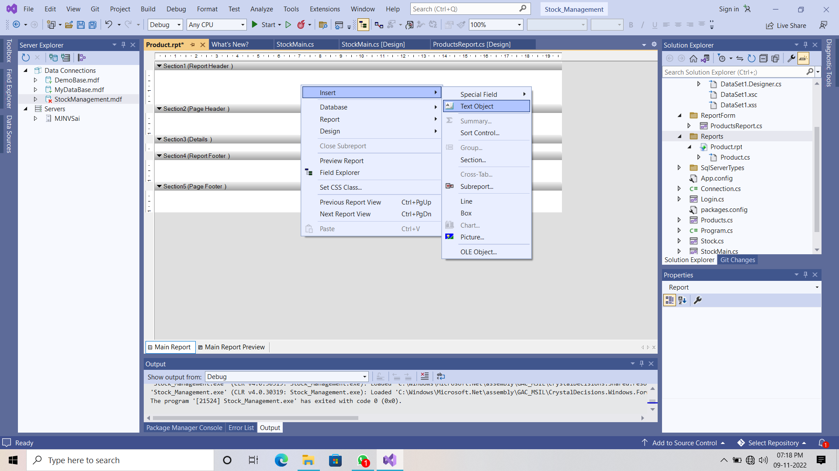

1. The final report template will be like below one.

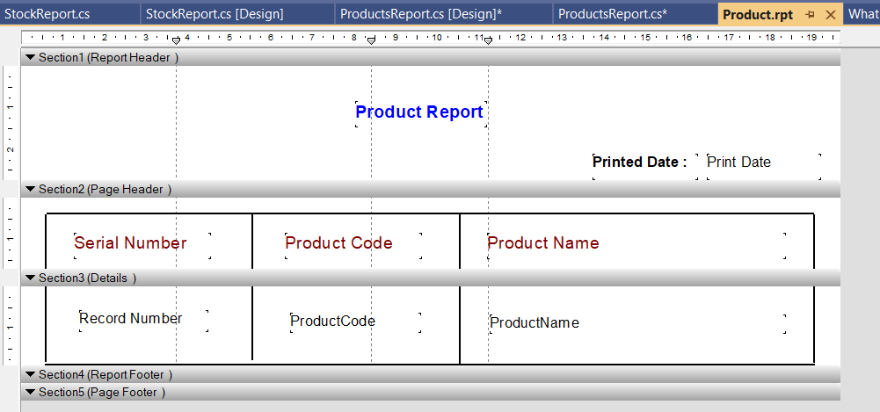

1. You can design the section 1, section 2, section 4, section 5 in the report in your way but the section 3 is connected to the dataset and database.
2. On left side panel click on the Field Explorer tab and then right click on the Database option then choose “ database expert “

Option.

1. Now send the “ Products table “ from the available data sources to the selected tables list then click on ok.

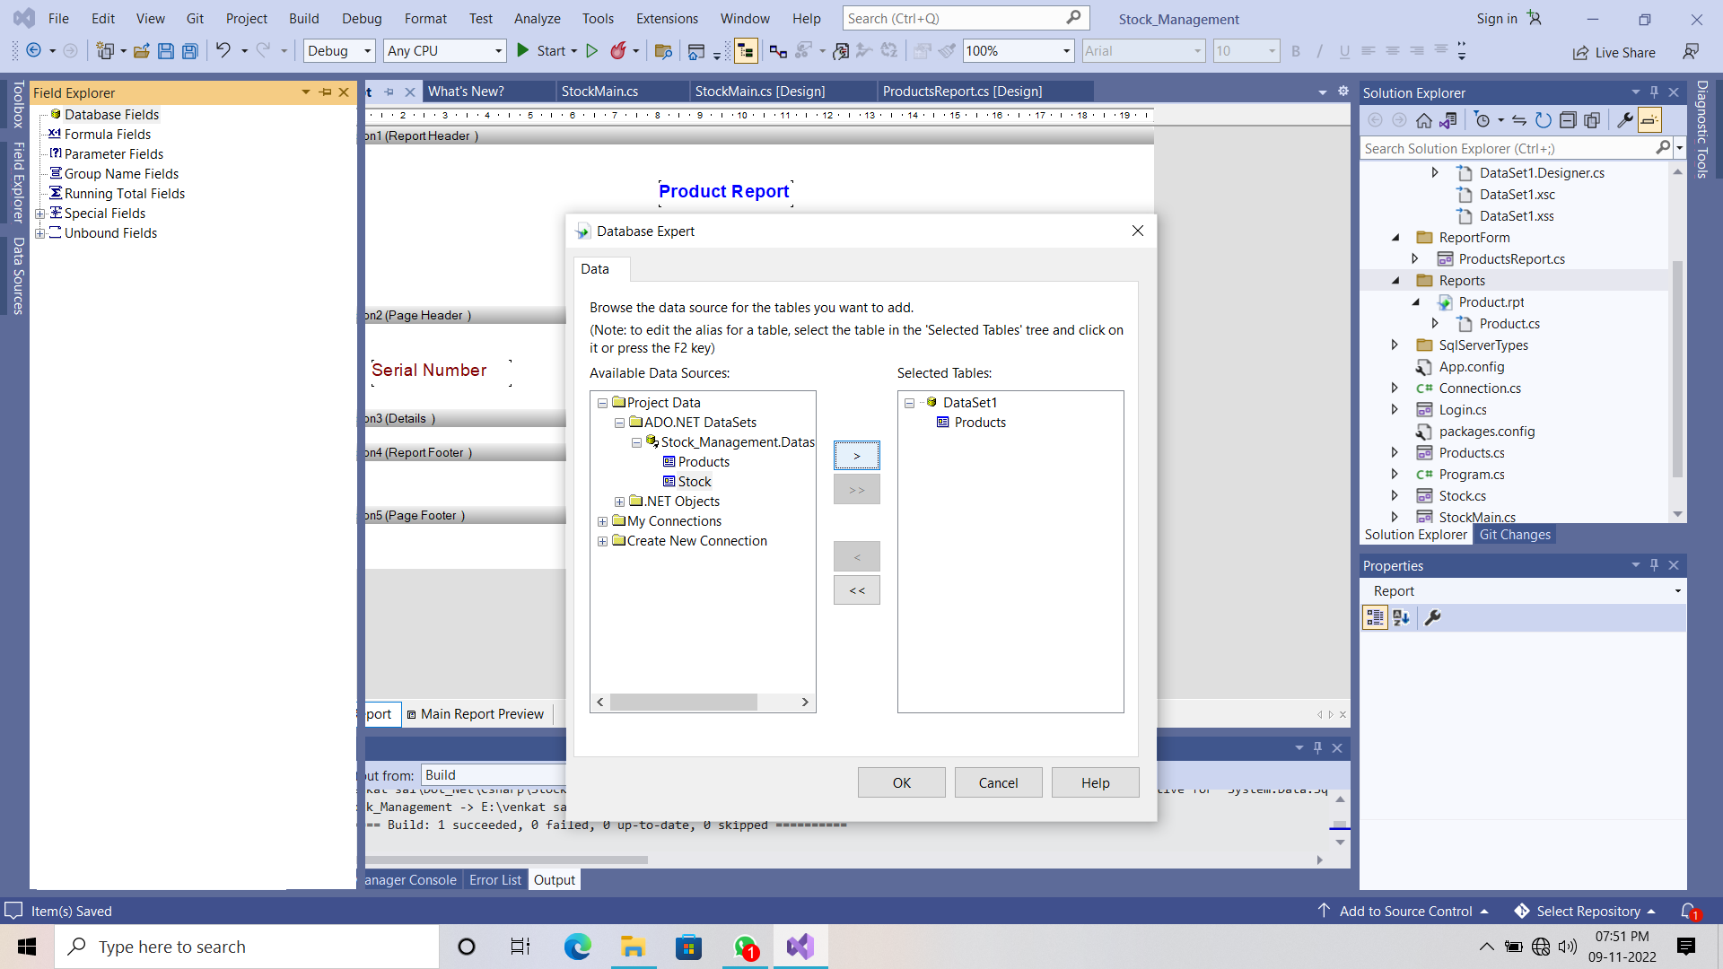

1. Now drag the Product code , product name fields from the database fields to the “ Details Section “.

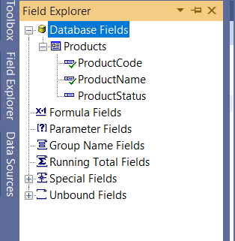

1. In details section you can record number box just like below one.

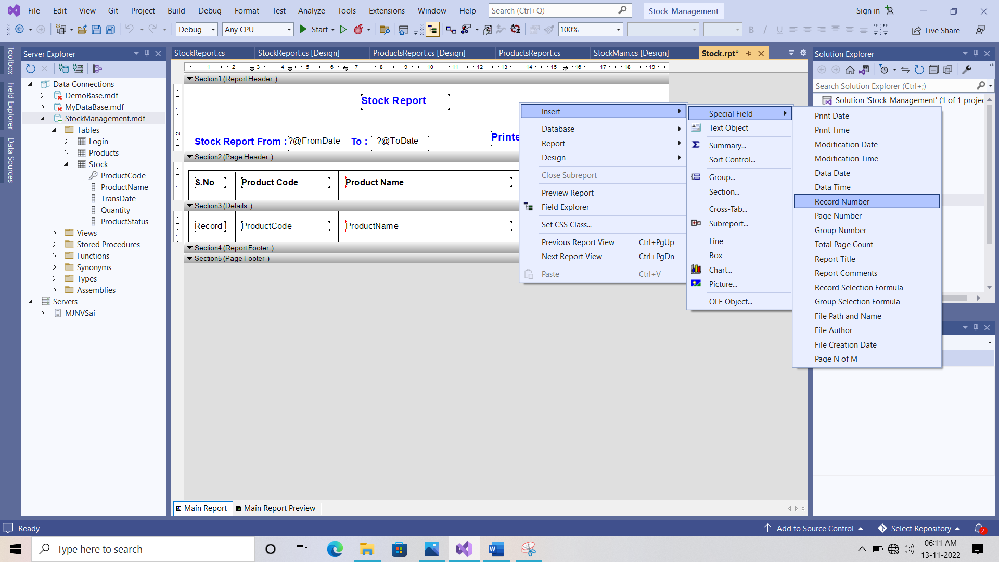

1. With this the Product report template is completed.

**Product Report Windows Form Part**

1. Right click on the reportform folder and add a windows form and save it as a name ProductReport.cs

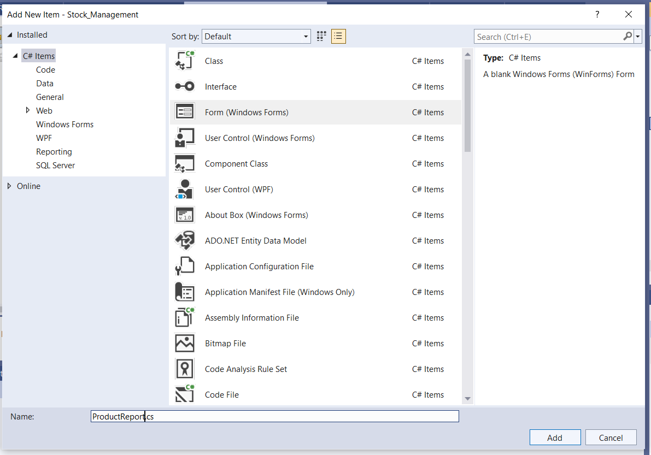

1. Now select the “ crystal report viwer tool “ from the tool box and drag into the windows form.

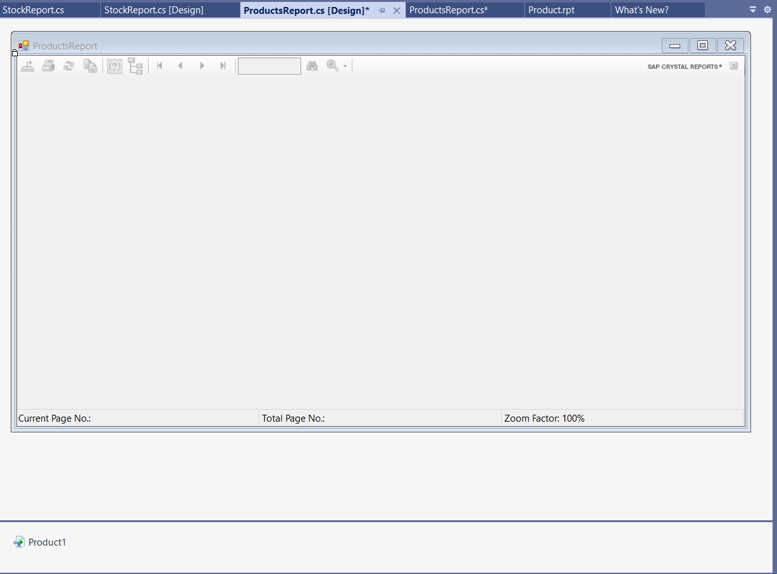

1. Double click on the top of the windows form then it will open the Form load section code.

|  |
| --- |
| **ProductReport.cs File Code**  using CrystalDecisions.CrystalReports.Engine;  using System;  using System.Collections.Generic;  using System.ComponentModel;  using System.Data;  using System.Data.SqlClient;  using System.Drawing;  using System.Linq;  using System.Text;  using System.Threading.Tasks;  using System.Windows.Forms;  using System.Data.SqlClient;  using Stock_Management.Datas;  namespace Stock_Management.ReportForm  {  public partial class ProductsReport : Form  {  ReportDocument cryrpt = new ReportDocument();  public ProductsReport()  {  InitializeComponent();  }  private void ProductsReport_Load(object sender, EventArgs e)  {  // Load Form  cryrpt.Load(@"E:\venkat sai\Dot_Net\Csharp\Stock_Management\Stock_Management\Reports\Product.rpt");  SqlConnection con = Connection.getConnection();  con.Open();  DataSet dst = new DataSet();  SqlDataAdapter sda = new SqlDataAdapter("Select * From Products", con);  DataTable dt = new DataTable();  sda.Fill(dt);  cryrpt.SetDataSource(dt);  crystalReportViewer1.ReportSource = cryrpt;  }  }  } |

**Stock Report Part**

1. Right click on the reports folder and then add an item crystal reporting and save as Stock.rpt

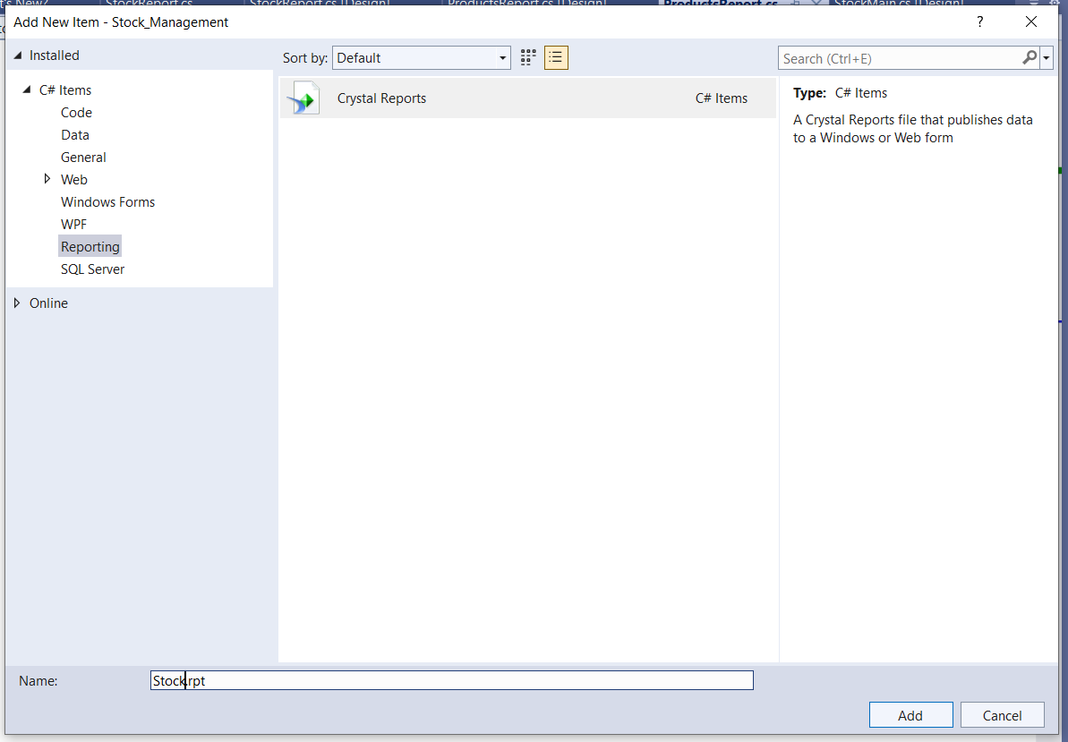

1. Select the blank report as an option and click on ok.

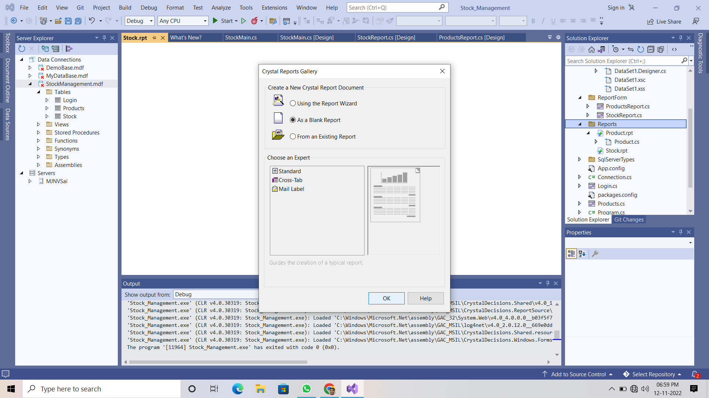

1. Now right click on the section 1 and select the page setup

Change the Letter format to the A4 sheet format.



1. Now design the stock report template in your way and in header section you have print the from date to the to date date.
2. We can achive that by using the parameter fields in the field explorer tab.

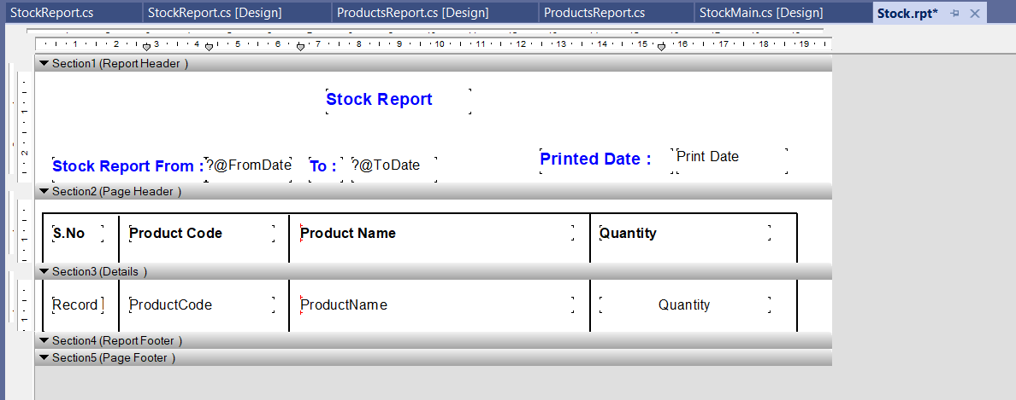

1. Click on field tools tab on the left side panel there right click on the parameter fields and click on NEW.
2. You have to 2 parameters fields one is FromDate field and ToDate Field.

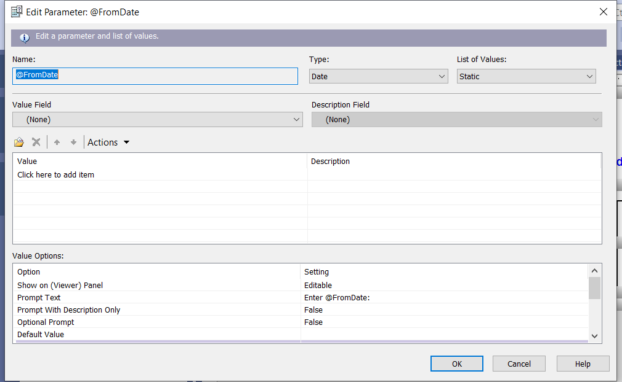

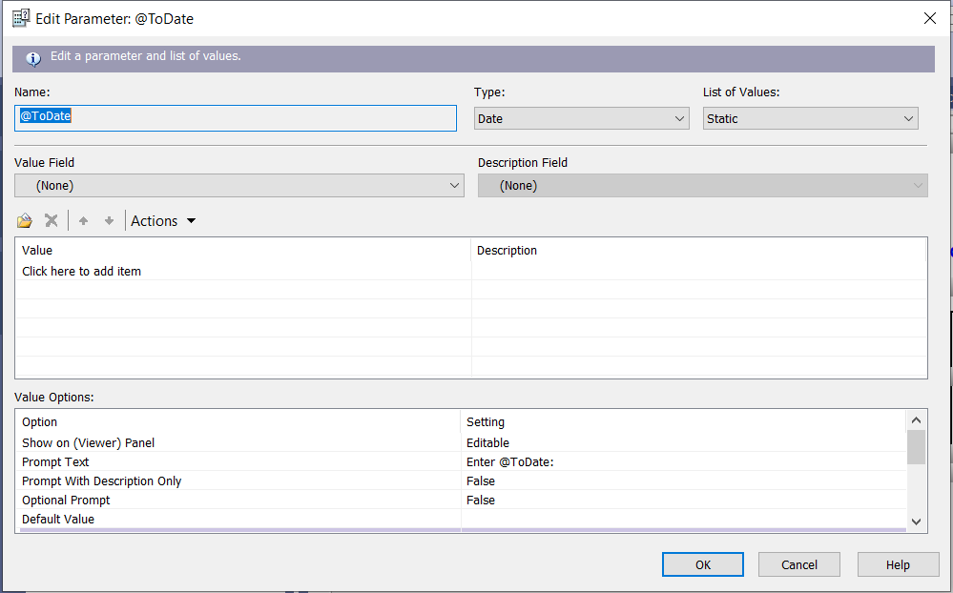

1. After adding both parameters into the parameter fields. Just drag the FromDate and ToDate fields from the parameter fields to the Section 1 (Report header ).
2. Now right click on the database fields and choose the database expert option.
3. Now send the “ Products table “ from the available data sources to the selected tables list then click on ok.

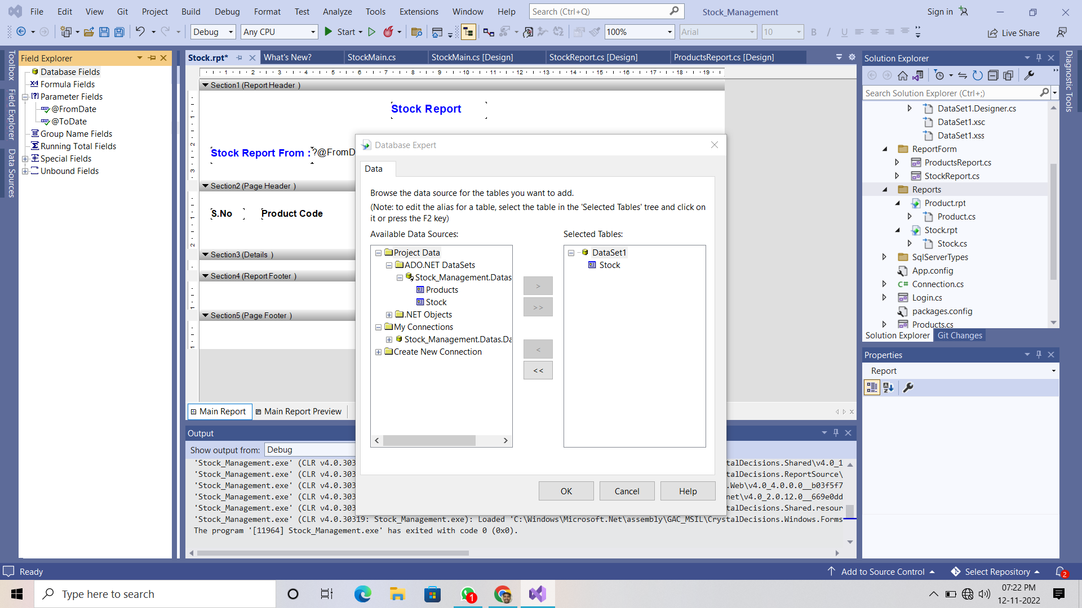

1. Now drag the Product code , product name, quantity fields from the database fields to the “ Details Section “.

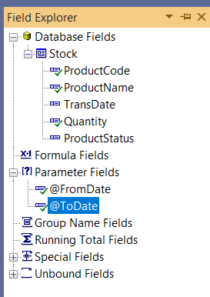

1. In details section you can record number box just like below one.



1. With these the Stock report template is completed.

**Stock Report Windows Form Part**

1. Right click on the reportform folder and add a windows form and save it as a name StockReport.cs

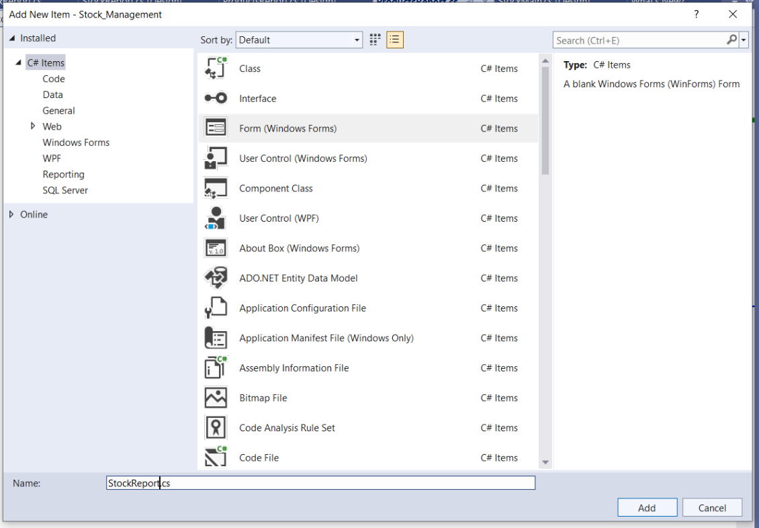

1. Now select the “ crystal report viwer tool “ from the tool box and drag into the windows form and design the form just like below one..

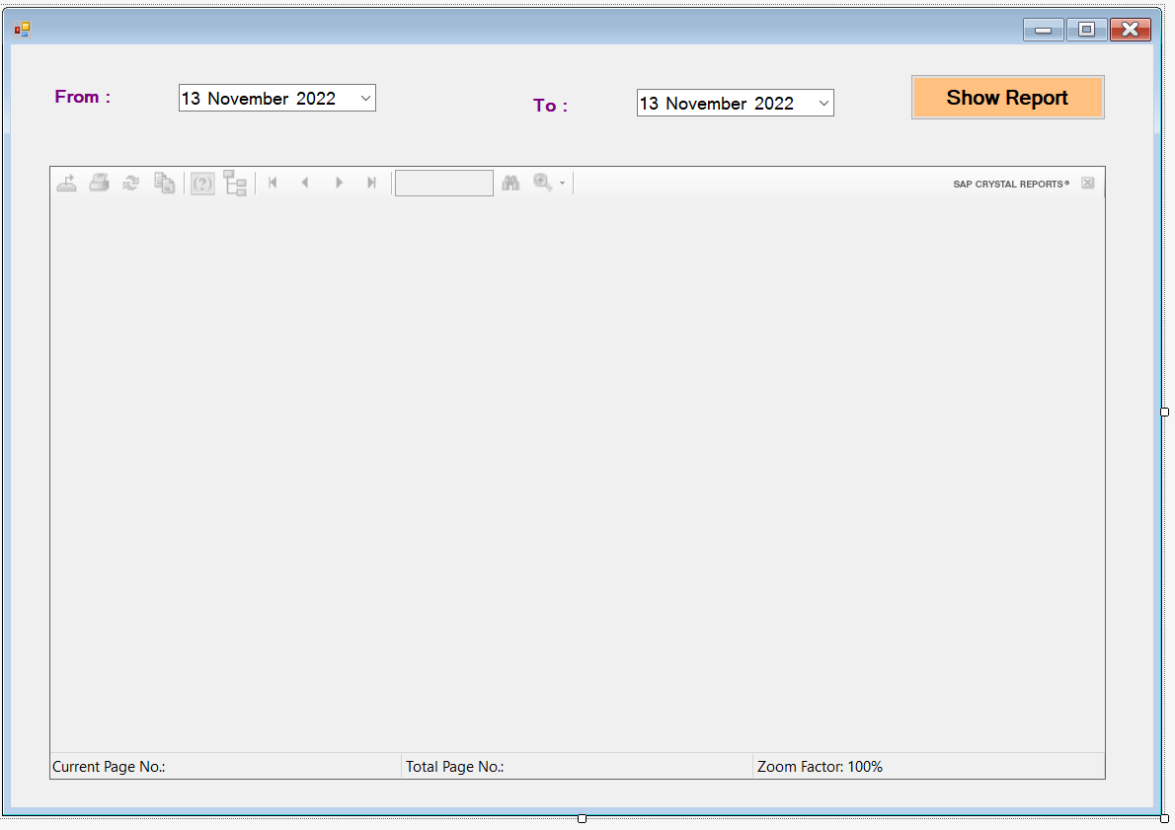

1. Double click on the Show report button then it will open the Button section code.

|  |
| --- |
| **StockReport.cs Form Code**  using CrystalDecisions.CrystalReports.Engine;  using System;  using System.Collections.Generic;  using System.ComponentModel;  using System.Data;  using System.Drawing;  using System.Linq;  using System.Text;  using System.Threading.Tasks;  using System.Windows.Forms;  using System.Data.SqlClient;  namespace Stock_Management.ReportForm  {  public partial class StockReport : Form  {  ReportDocument crystal = new ReportDocument();  public StockReport()  {  InitializeComponent();  }  private void StockReport_Load(object sender, EventArgs e)  {  // Form load Section  }  private void button1_Click(object sender, EventArgs e)  {  // Show Report  crystal.Load(@"E:\venkat sai\Dot_Net\Csharp\Stock_Management\Stock_Management\Reports\Stock.rpt");  SqlConnection con = Connection.getConnection();  con.Open();  DataSet dst = new DataSet();  SqlDataAdapter sda = new SqlDataAdapter("Select * From Stock where Cast( TransDate as Date) between '" + dateTimePicker1.Value.ToString("MM/dd/yyyy") + "' and '" + dateTimePicker2.Value.ToString("MM/dd/yyyy") + "'", con);  sda.Fill(dst, "Stock");  crystal.SetDataSource(dst);  crystal.SetParameterValue("@FromDate", dateTimePicker1.Value.ToString("dd/MM/yyyy"));  crystal.SetParameterValue("@ToDate", dateTimePicker2.Value.ToString("dd/MM/yyyy"));  crystalReportViewer1.ReportSource = crystal;  }  }  } |

**Update the StockMain Windows Form Part**

|  |
| --- |
| **Updated StockMain.cs Form Code**  using System;  using System.Collections.Generic;  using System.ComponentModel;  using System.Data;  using System.Drawing;  using System.Linq;  using System.Text;  using System.Threading.Tasks;  using System.Windows.Forms;  namespace Stock_Management  {  public partial class StockMain : Form  {  public StockMain()  {  InitializeComponent();  }  private void productsToolStripMenuItem_Click(object sender, EventArgs e)  {  // products option in Navbar  Products pro = new Products();  pro.MdiParent = this;  pro.StartPosition = FormStartPosition.CenterScreen;  pro.Show();  }  bool close = true;  private void StockMain_FormClosing(object sender, FormClosingEventArgs e)  {  if(close)  {  DialogResult result = MessageBox.Show(" Are You Sure Want To Exit ", "Exit", MessageBoxButtons.YesNo, MessageBoxIcon.Question);  if (result == DialogResult.Yes)  {  close = false;  Application.Exit();  }  else  {  e.Cancel = true;  }  }  }  private void stockToolStripMenuItem_Click(object sender, EventArgs e)  {  // Stock  Stock stk = new Stock();  stk.MdiParent = this;  stk.StartPosition = FormStartPosition.CenterScreen;  stk.Show();  }  private void productListToolStripMenuItem_Click(object sender, EventArgs e)  {  // Products Report  ReportForm.ProductsReport prod = new ReportForm.ProductsReport();  prod.MdiParent = this;  prod.StartPosition = FormStartPosition.CenterScreen;  prod.Show();  }  private void stockListToolStripMenuItem_Click(object sender, EventArgs e)  {  // Stock Report  ReportForm.StockReport prod = new ReportForm.StockReport();  prod.MdiParent = this;  prod.StartPosition = FormStartPosition.CenterScreen;  prod.Show();  }  }  } |

**Outputs :**

**Invalid Login :**

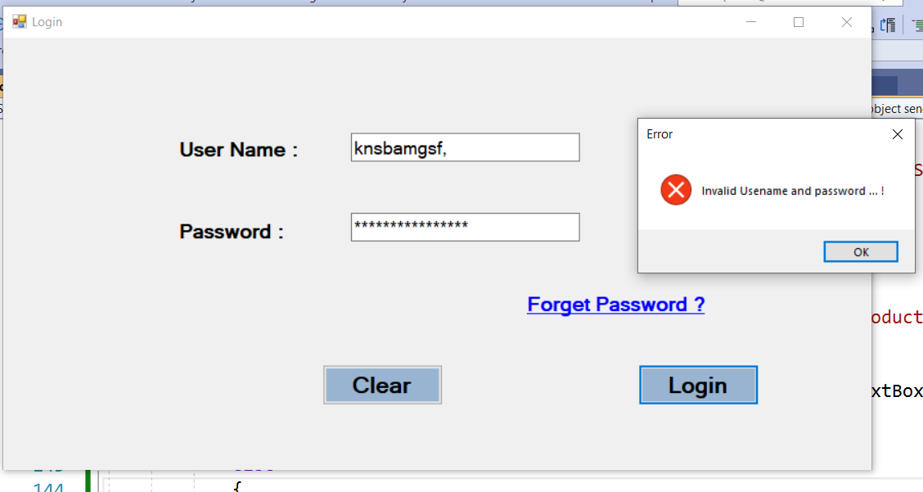

**Valid Login :**

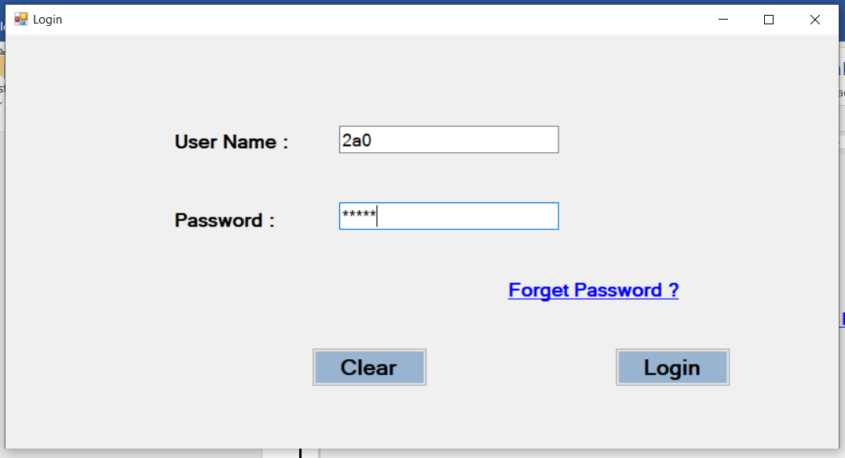

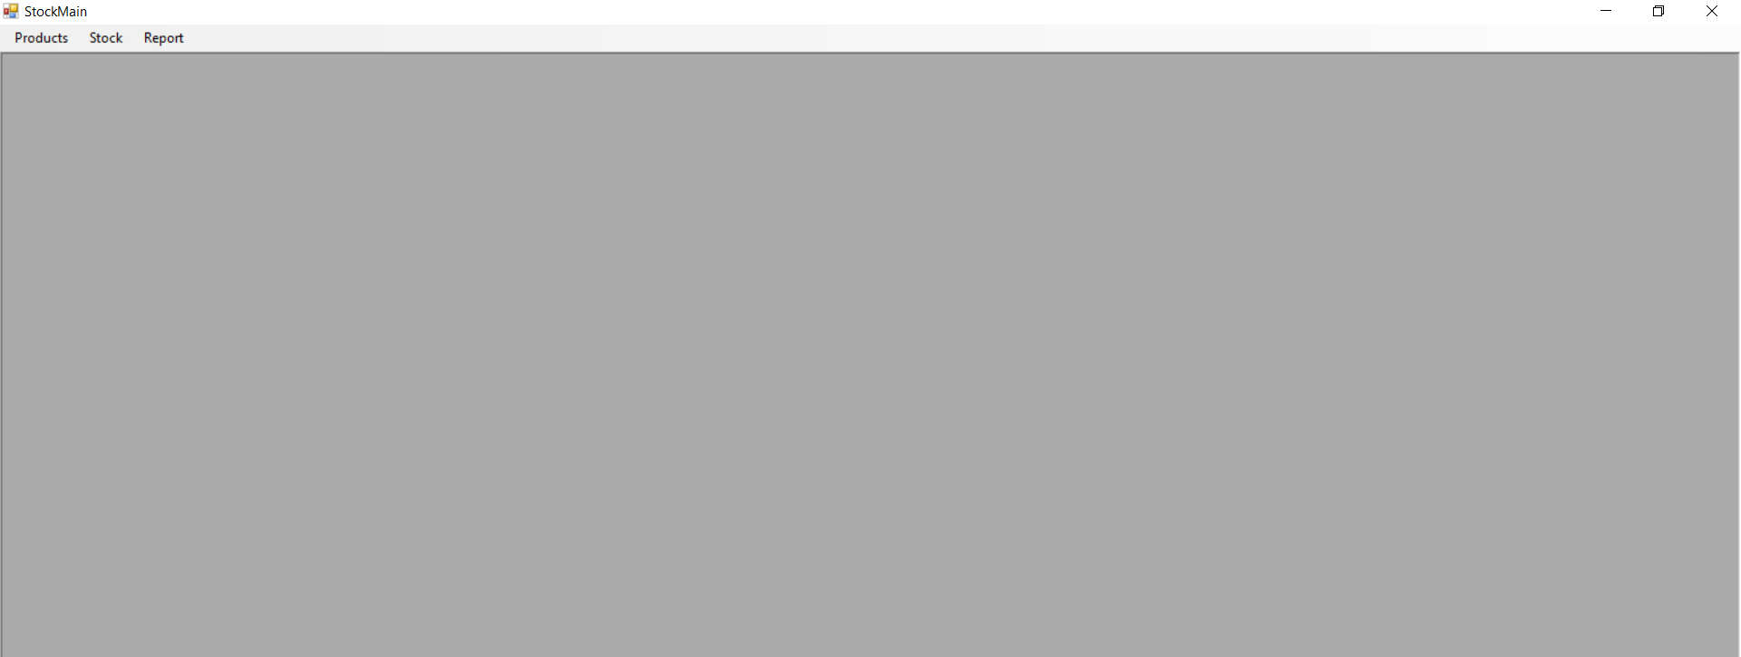

**Products Form :**

**Button : Add**

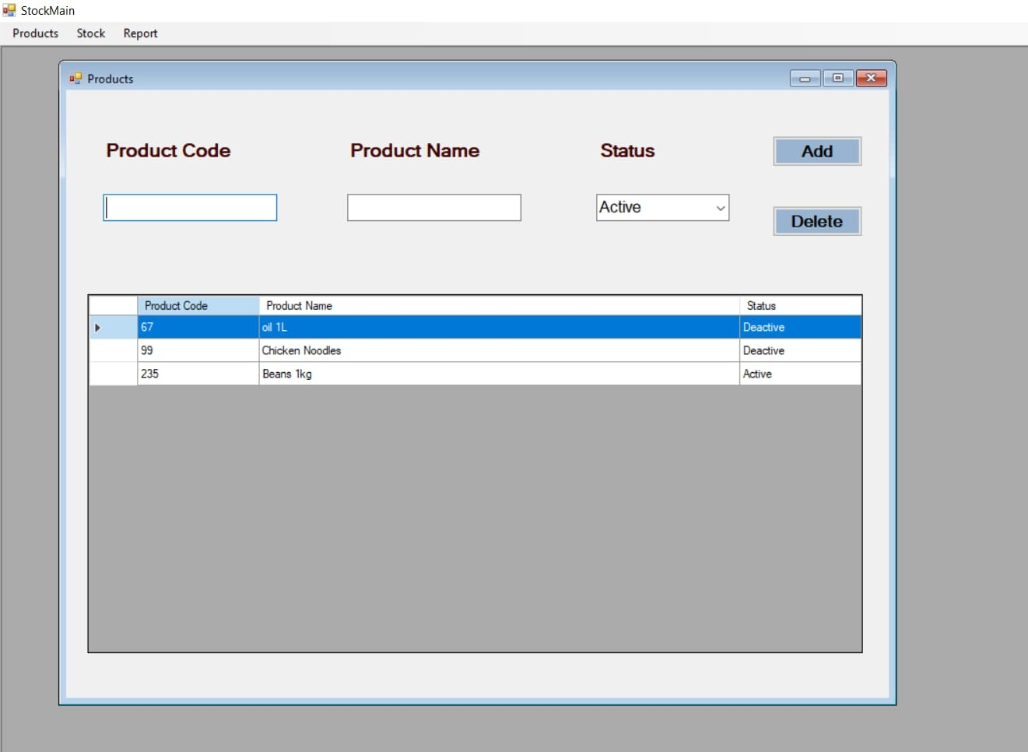

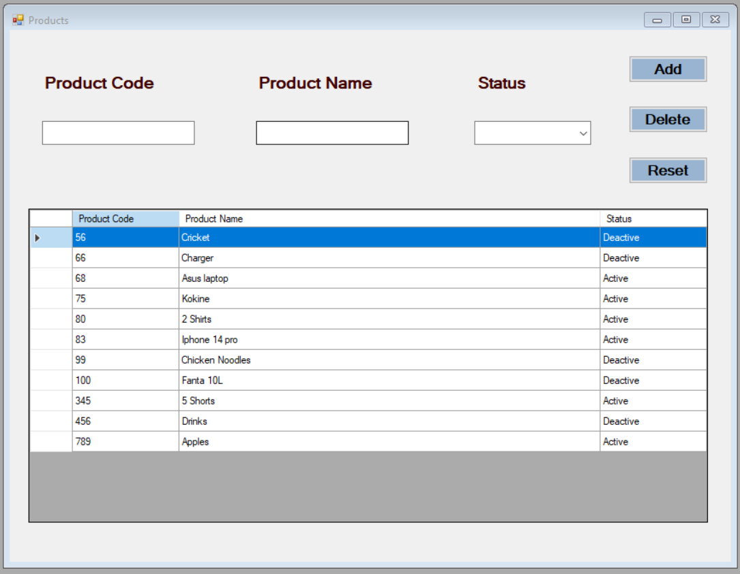

**Button : Update**

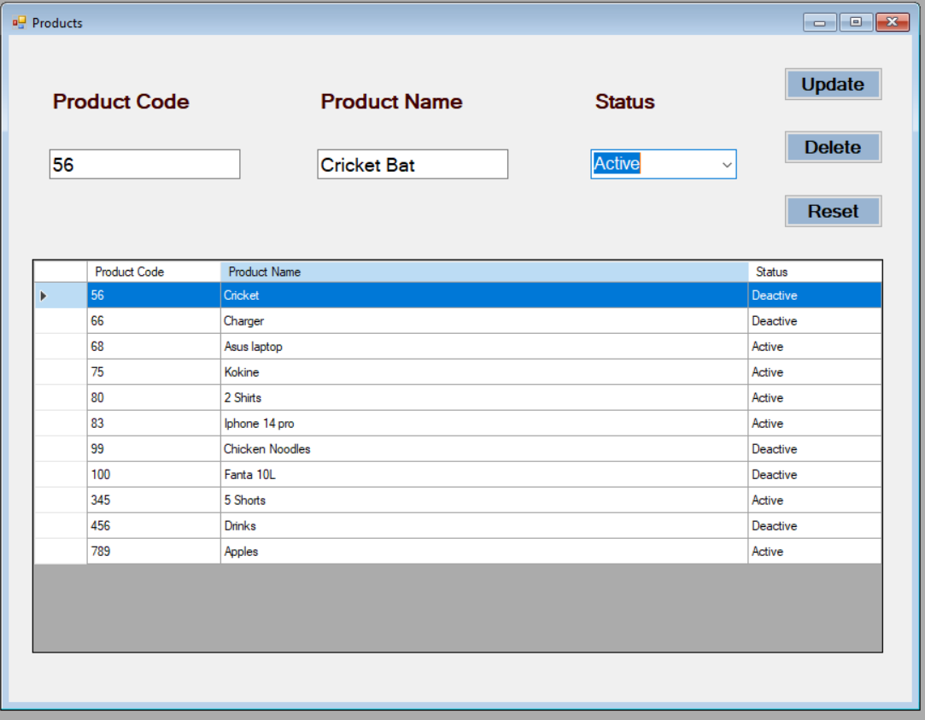

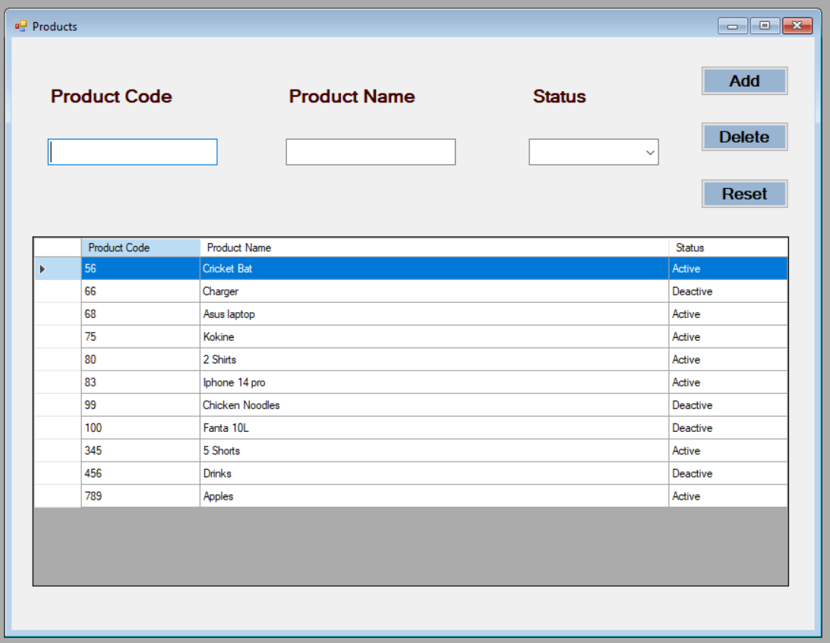

**Button : Delete**

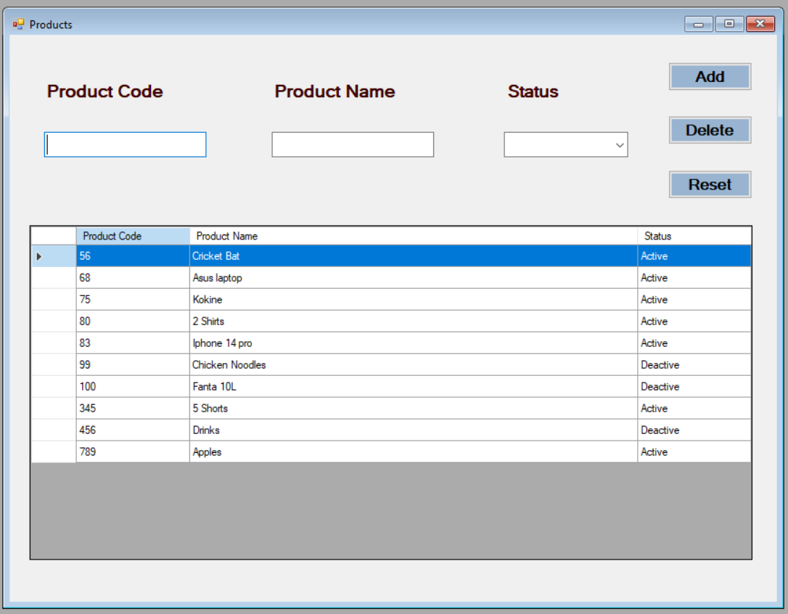

**Stock Form :**

**Button : Add**

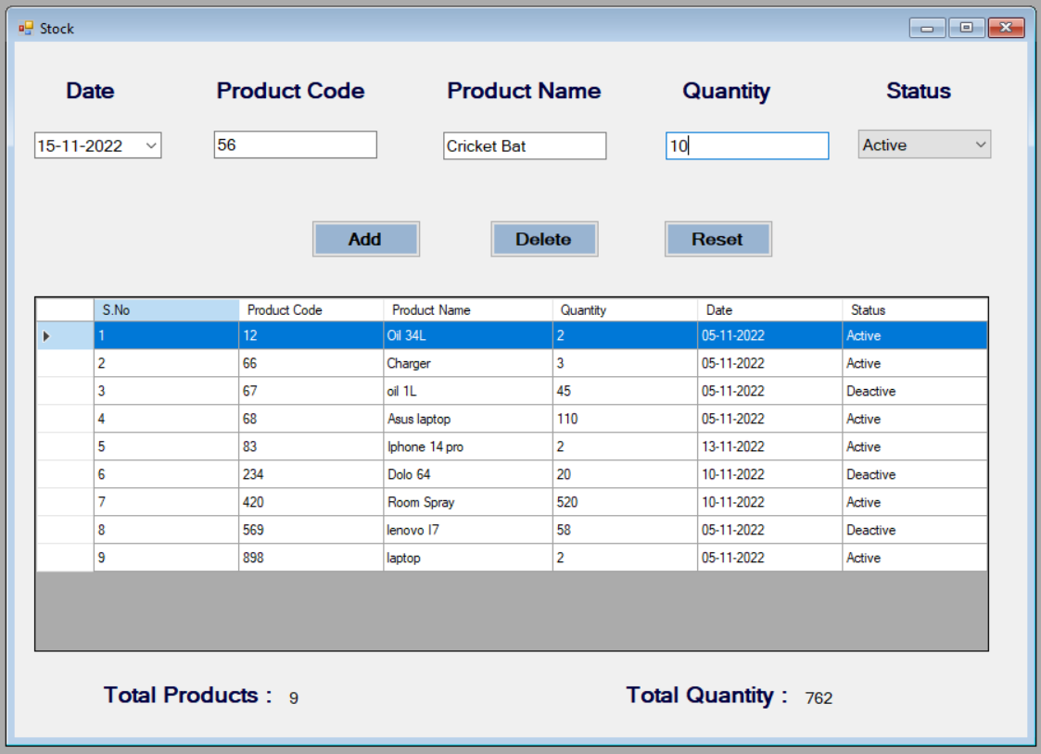

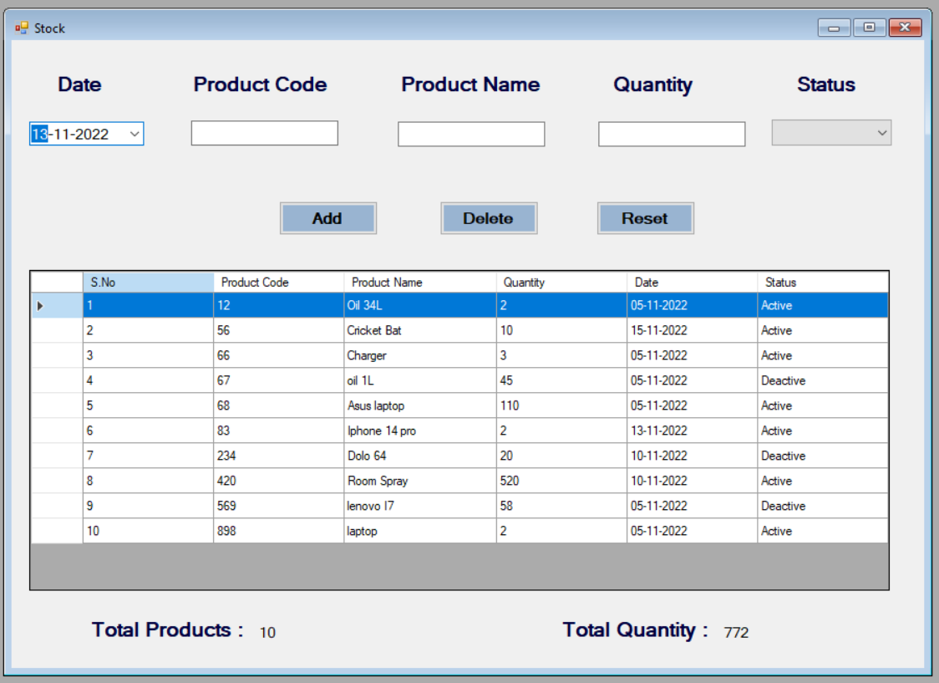

**Button : Update**

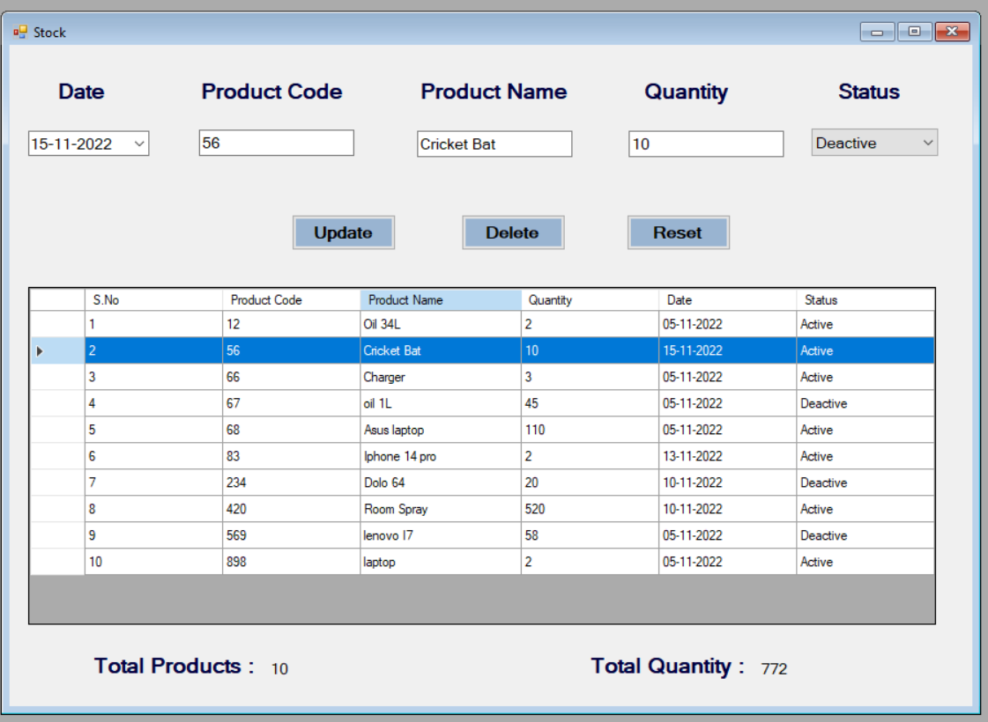

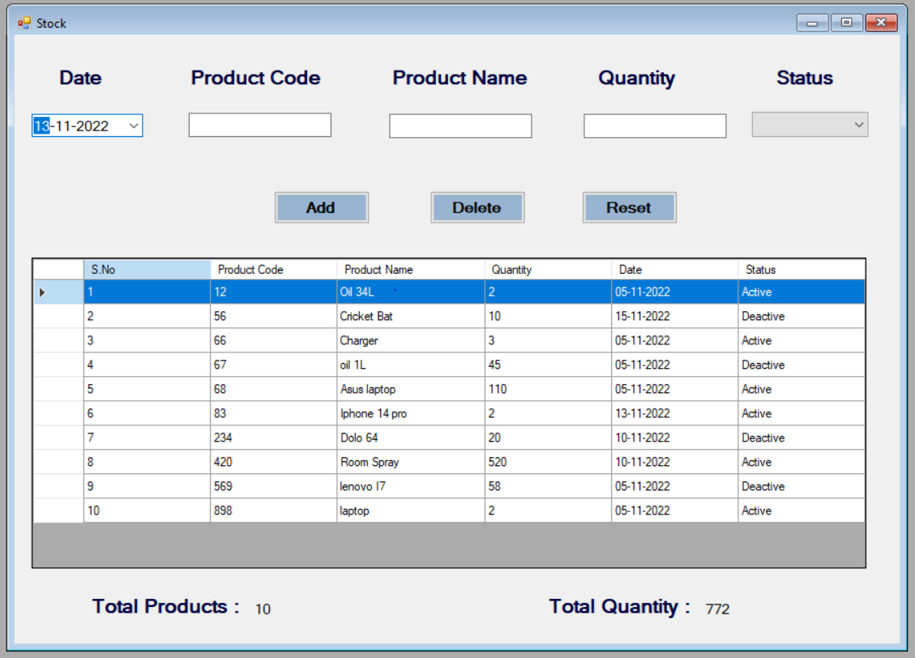

**Button : Delete**

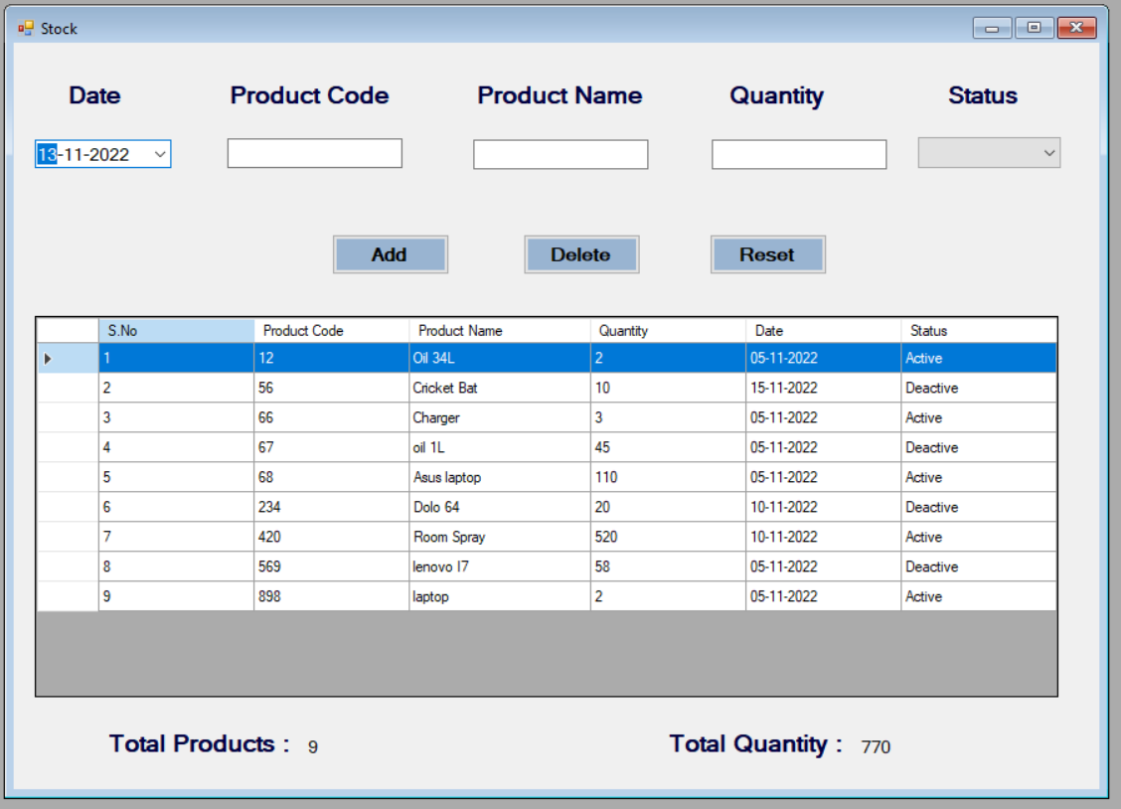

**Product List Report :**

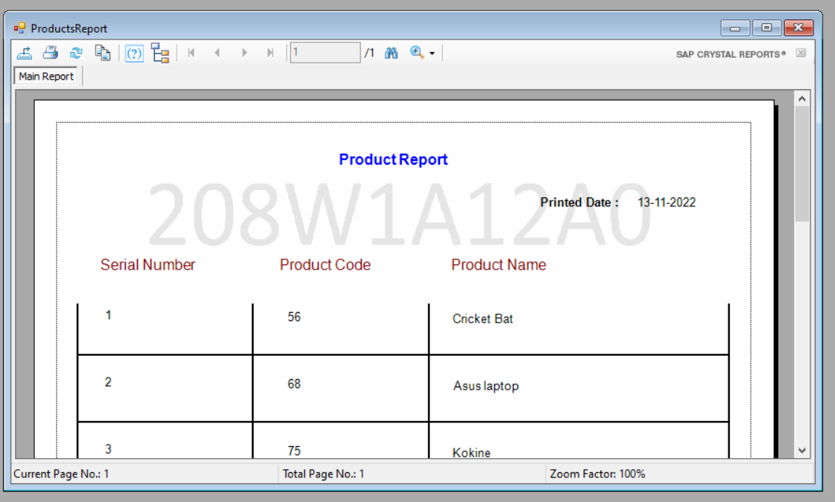

**Stock List Report :**

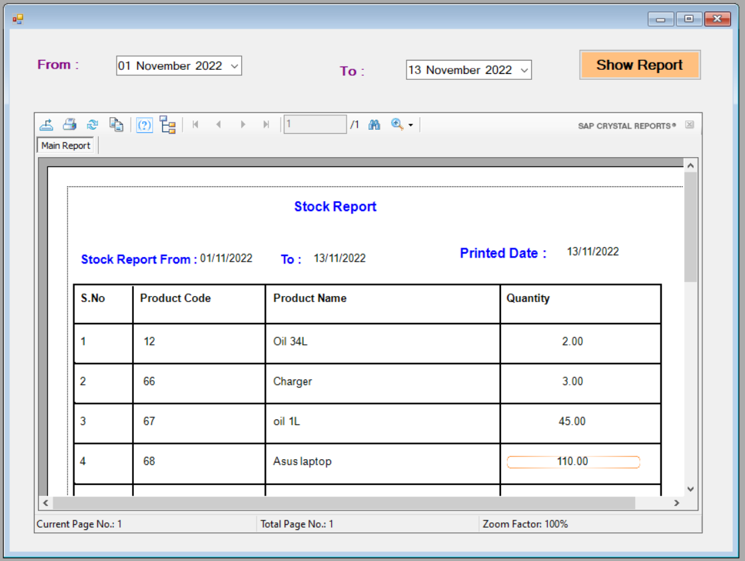

**END OF TASK**